## Q1 Virtual Machine Setup

a. Linux White Paper - Downloaded from

<http://www.oracle.com/us/technologies/virtualization/oracle-vm-virtualbox-overview-2981353.pdf>

b. Download Oracle VirtualBox 6.0

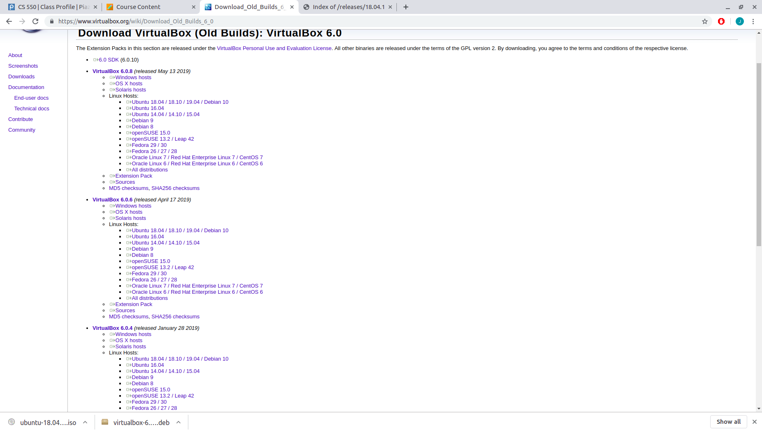

c. Install VirtualBox

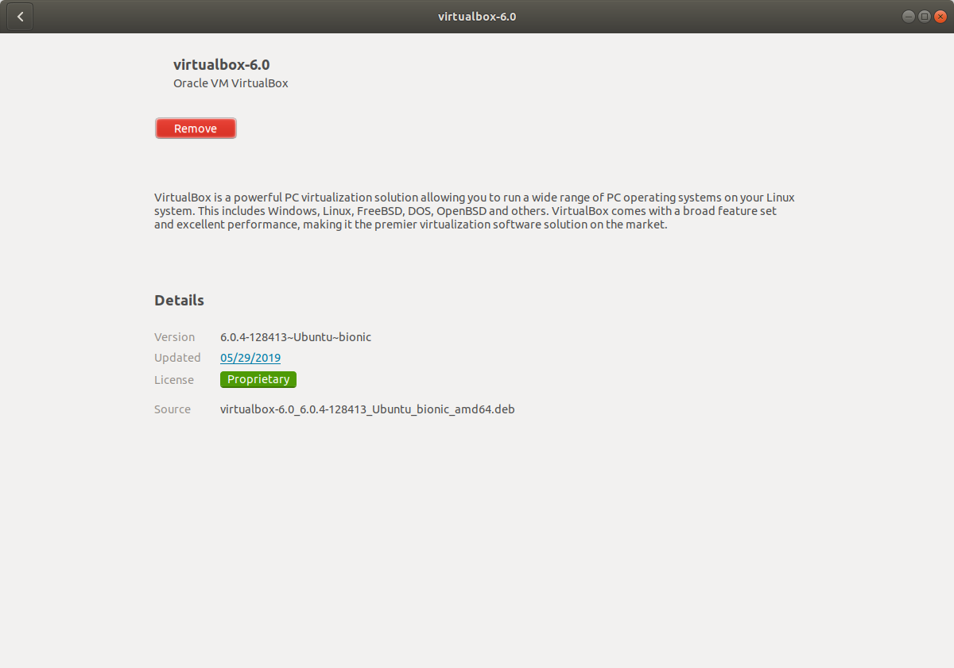

d. Download Ubuntu 18.04 Linux ISO Image

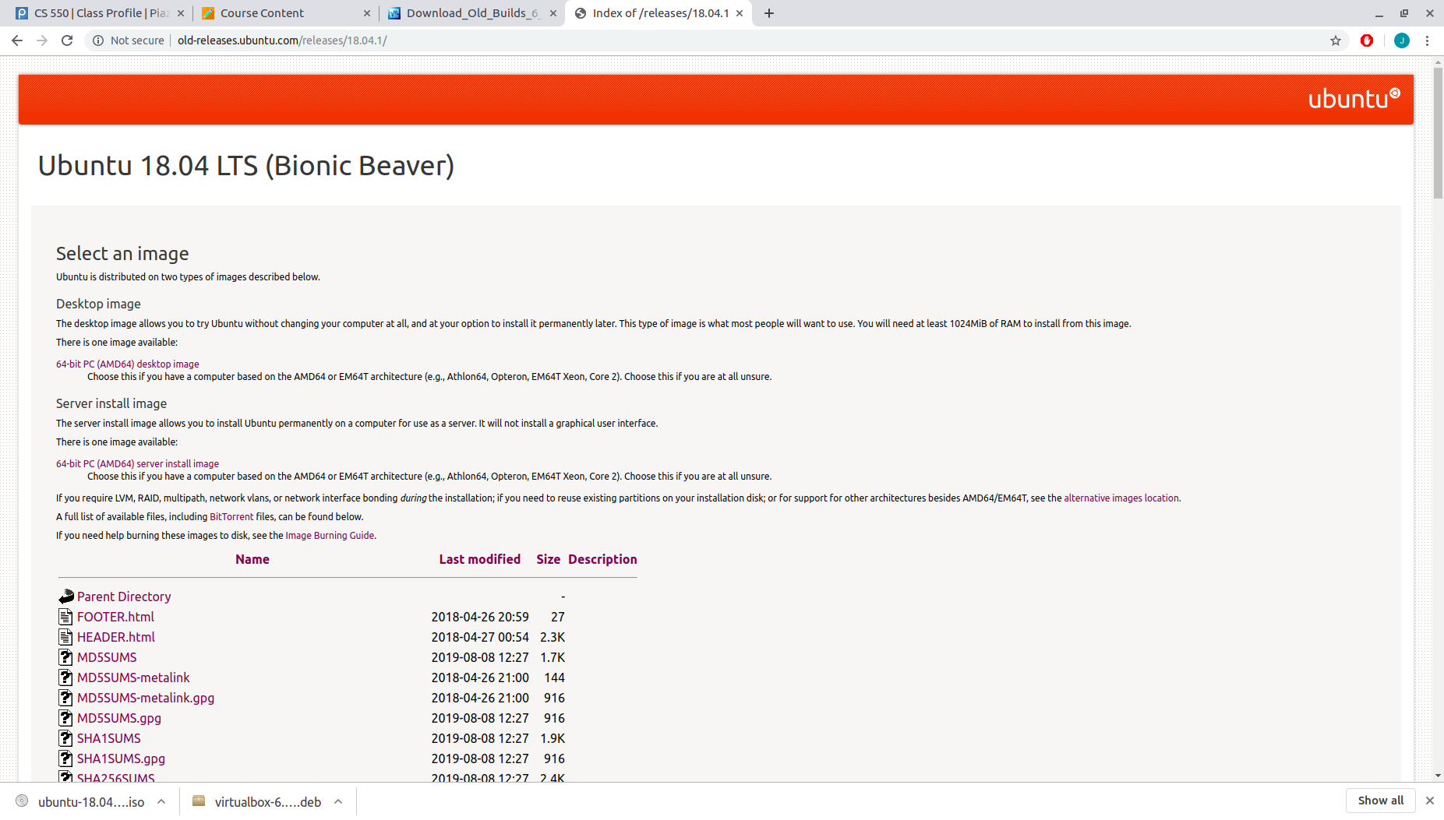

e. Virtual Machine Creation

e.1.

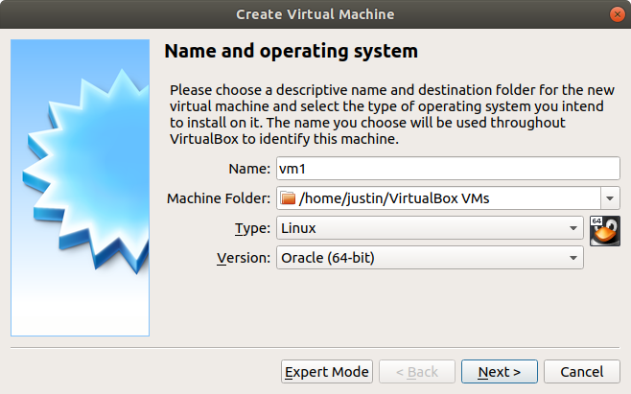

e.2. Memory allocation - 4GB

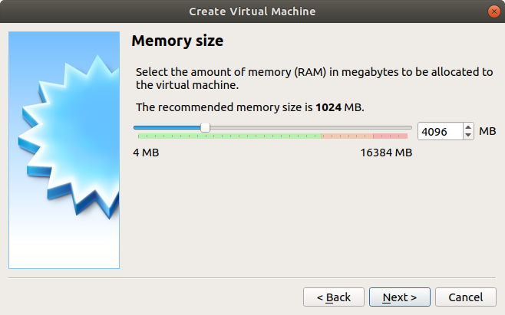

e.3. Virtual hardisk creation

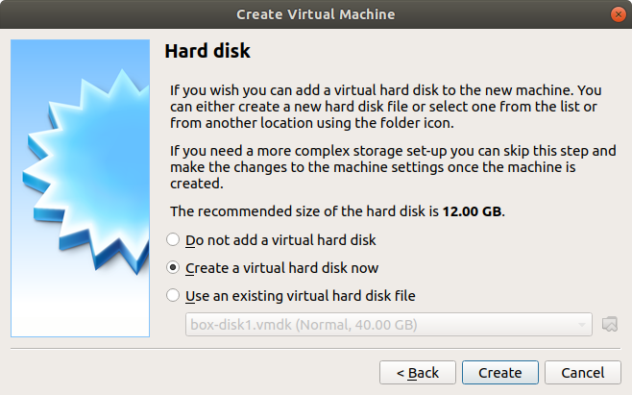

e.4. Virtual hardisk type - VDI

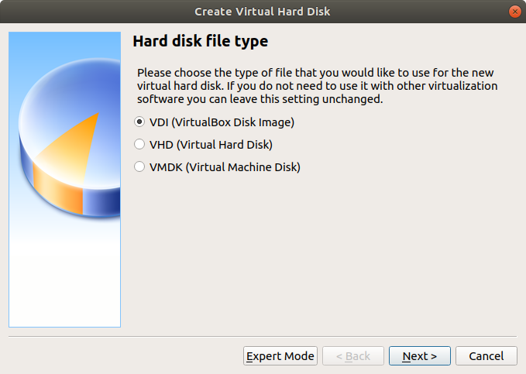

e.5. Dynamically allocated disk

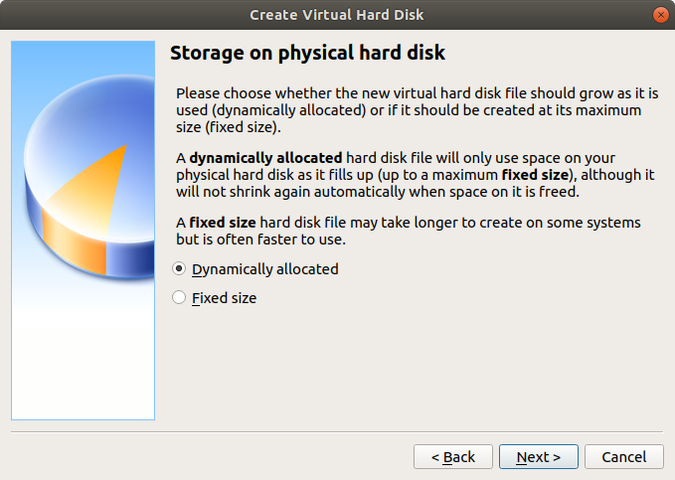

e.6. Disk size - 25.00GB

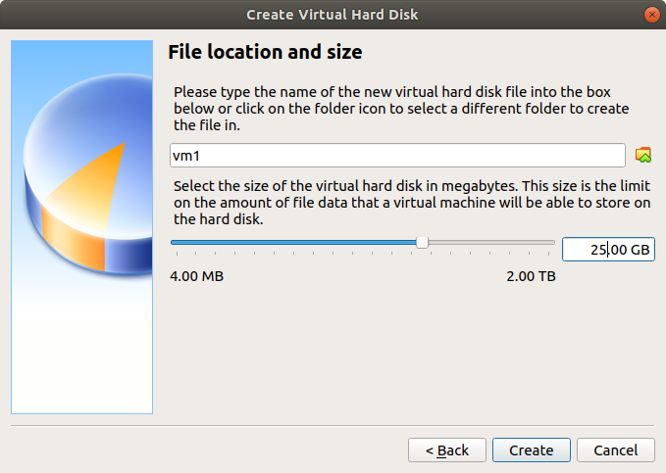

e.7. Processor - 1->2

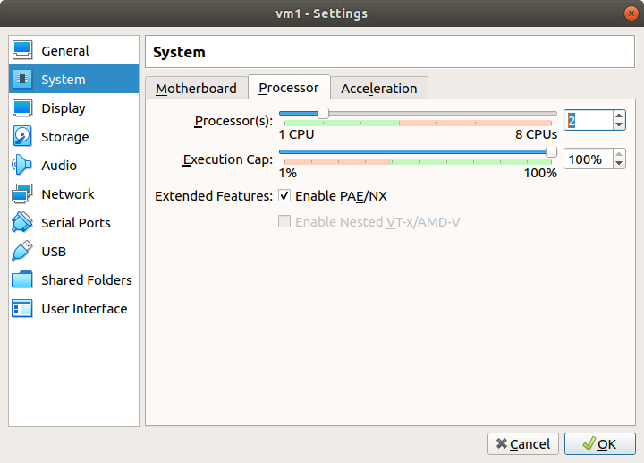

e.8. Network settings, NAT(adapter1) and NAT network(adapter2)

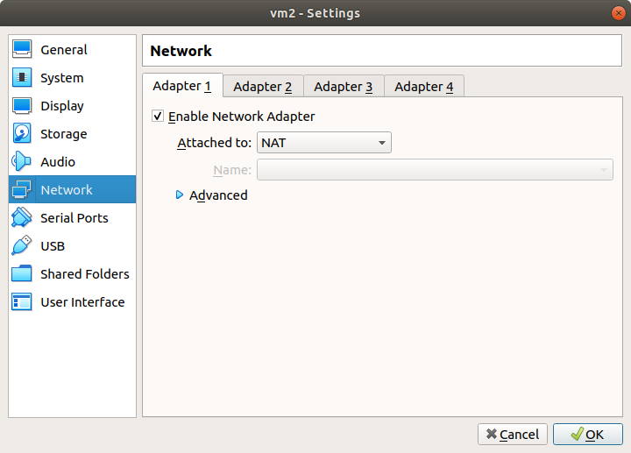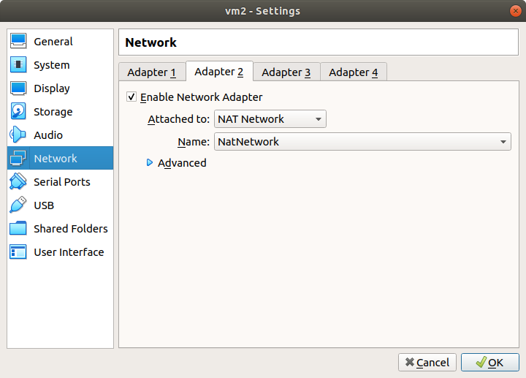

f. Ubuntu Installation

f.1. Select the downloaded ISO Image

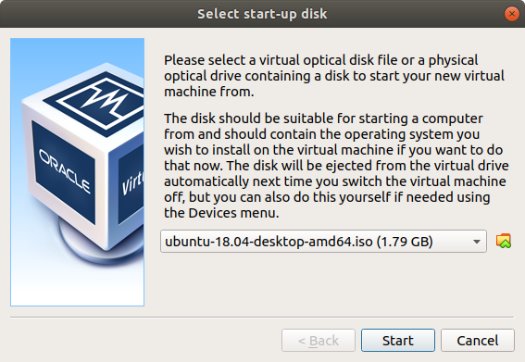

f.2. Setup user account

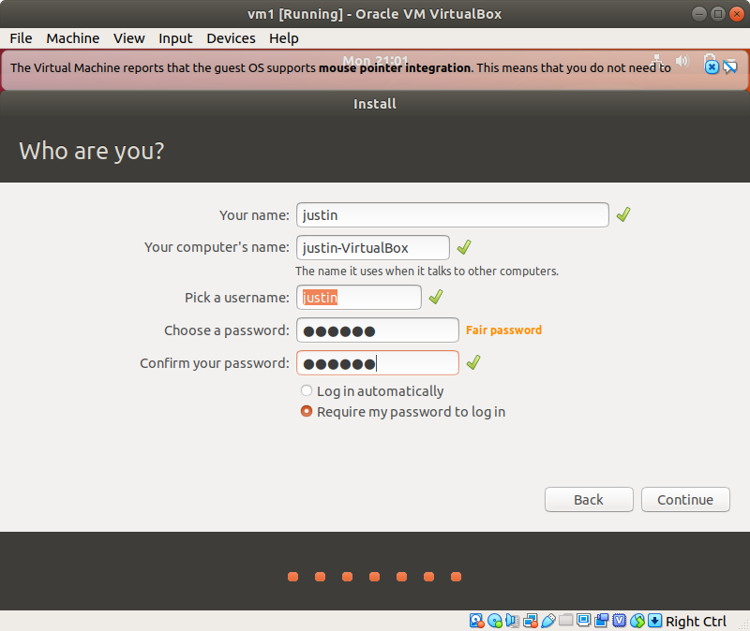

h, i. Turn on firewall (ufw) and block all ports. Open port for ssh and enable ssh access.

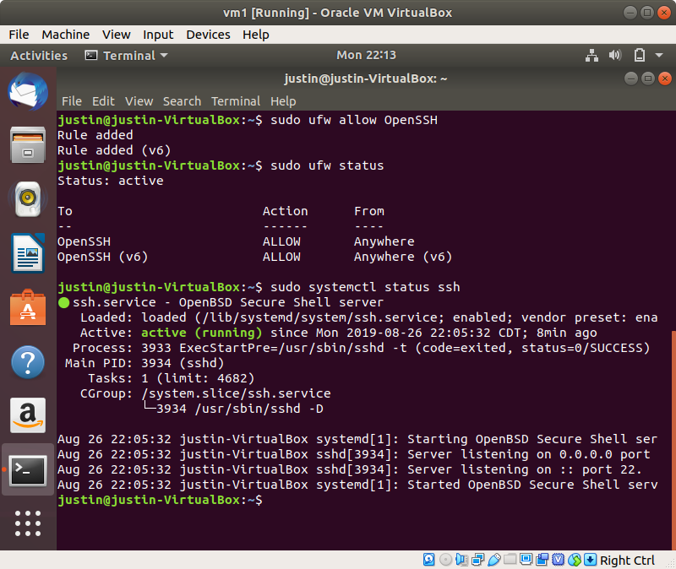

j. Create another VM with the same specification

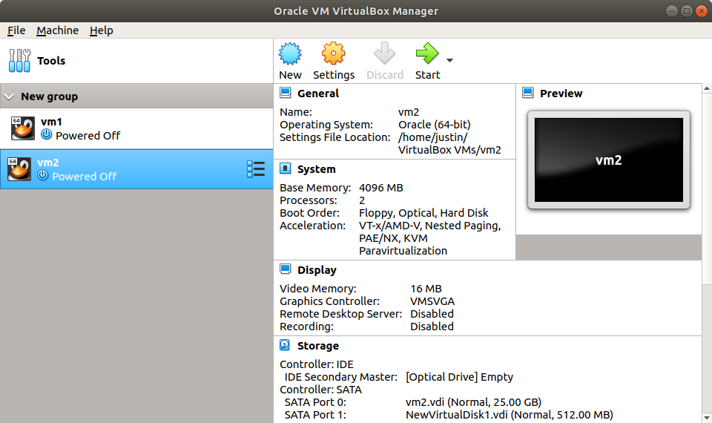

k. Create public/private keys, and install them for ssh authentication.

k.1. Create public/private key pair in vm2

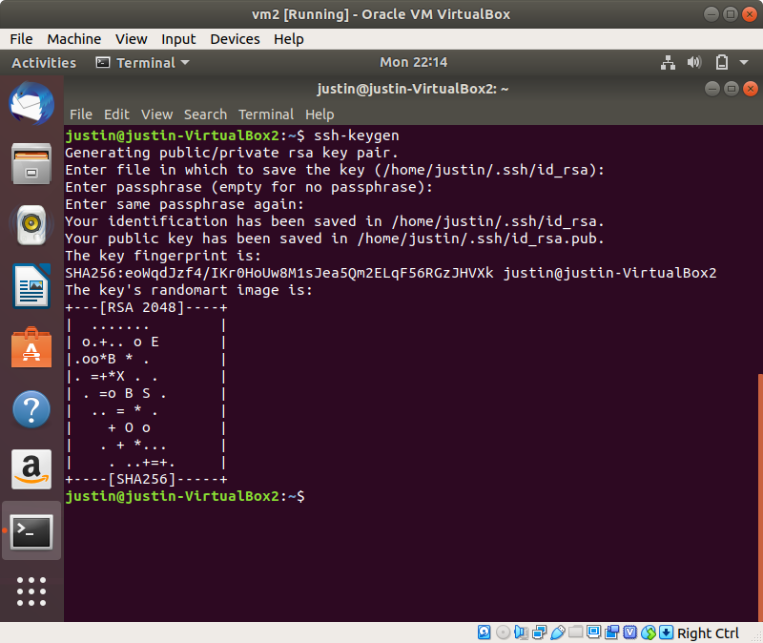

k.2. scp the public key from vm2 to vm1, and add the pub key to authorized_keys

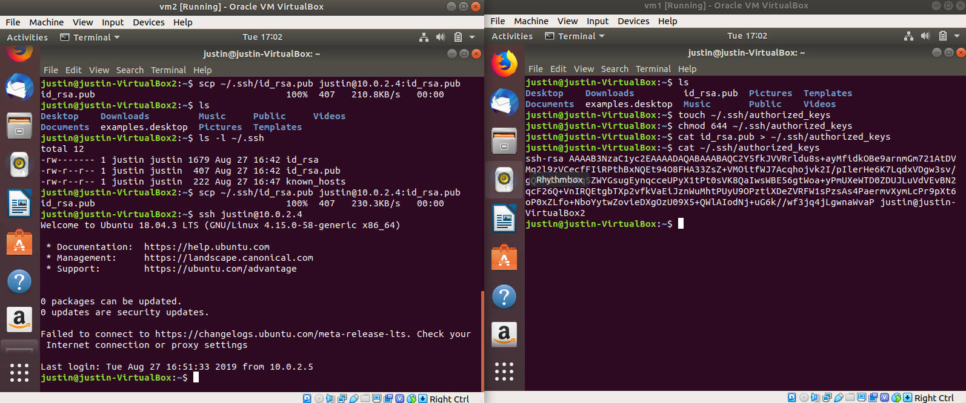

l. Login to vm1 from vm2, using the specified private key

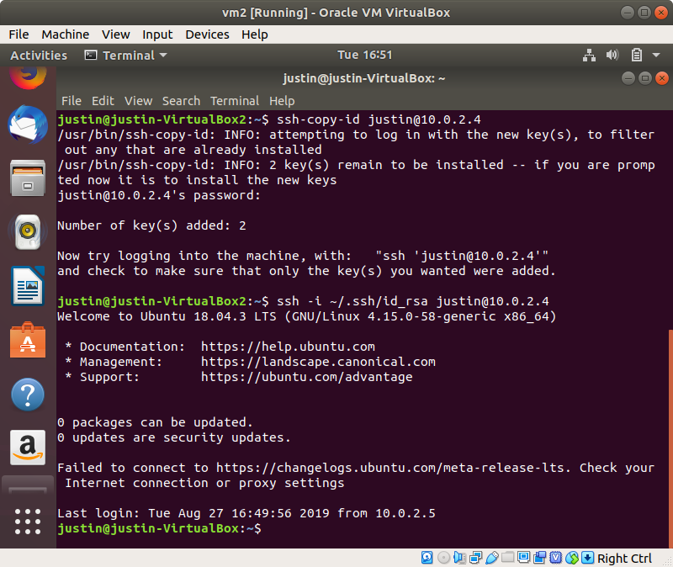Q2

a. ssh - Connect to a remove host using the ssh protocol

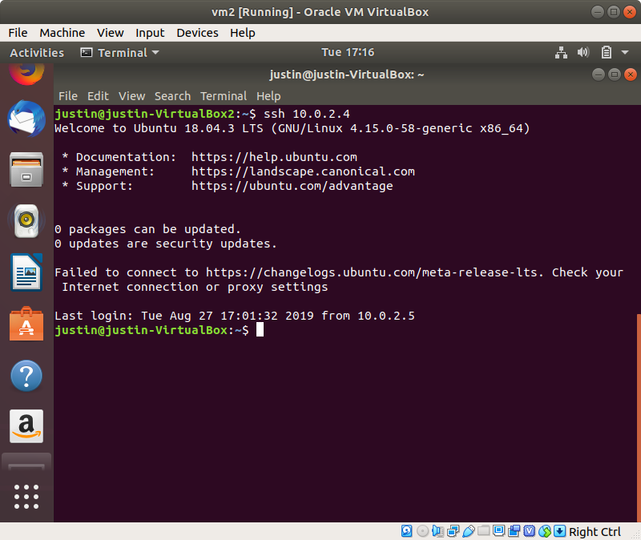t

b. ssh-keygen - create a public-private key pair for ssh authentication

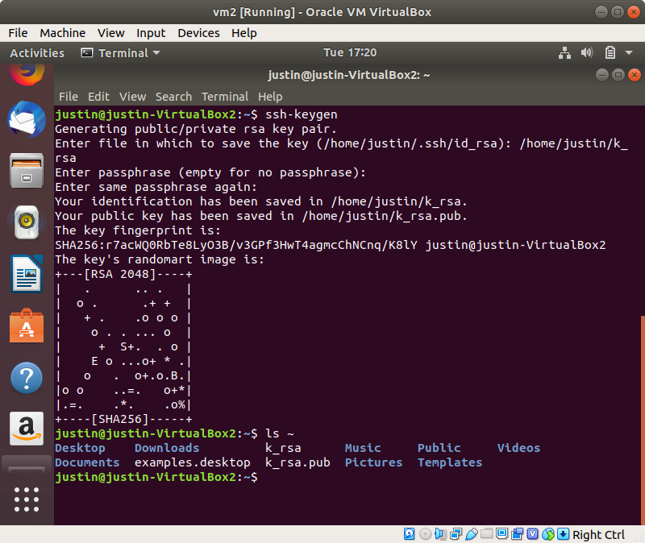

c. scp - copy files from remote to local, and vice versa

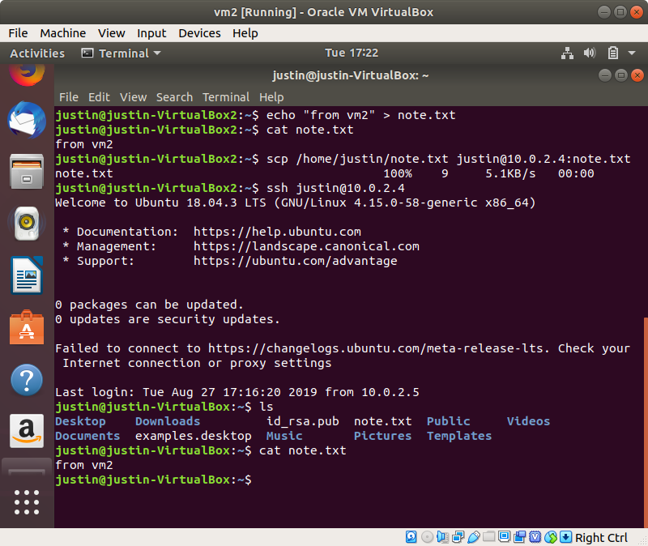

d. history - display previously inputted commands

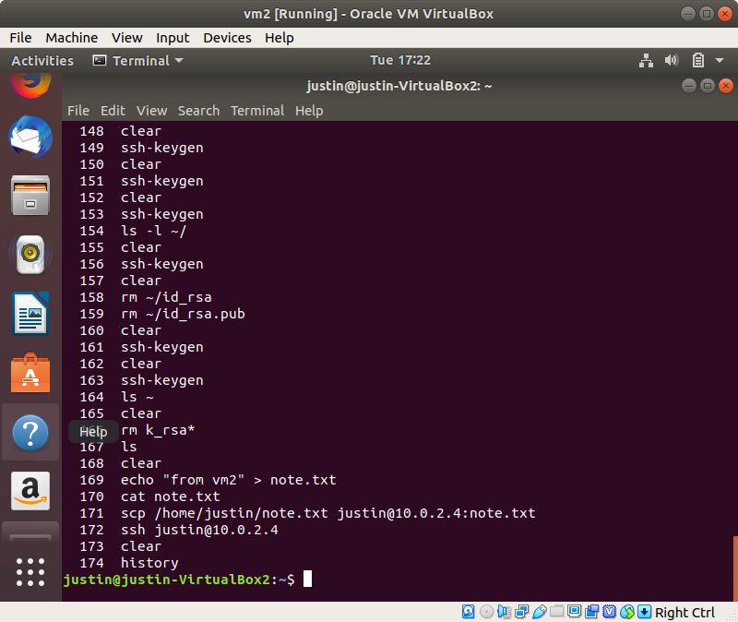

e. sudo - Execute commands at elevated privilege user

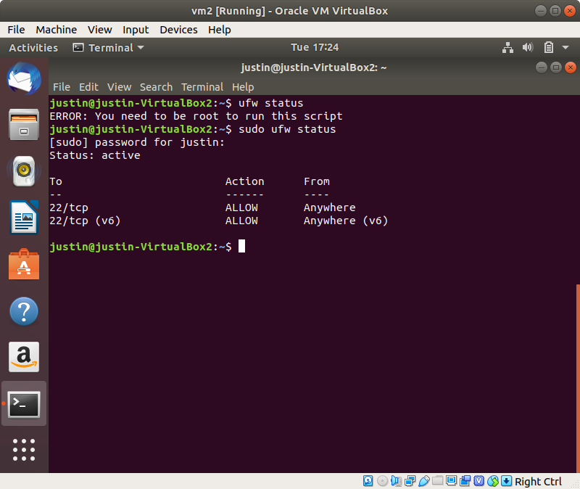

f. ip - display network adapter interface settings (ip masks, addresses - ip and MAC, etc)

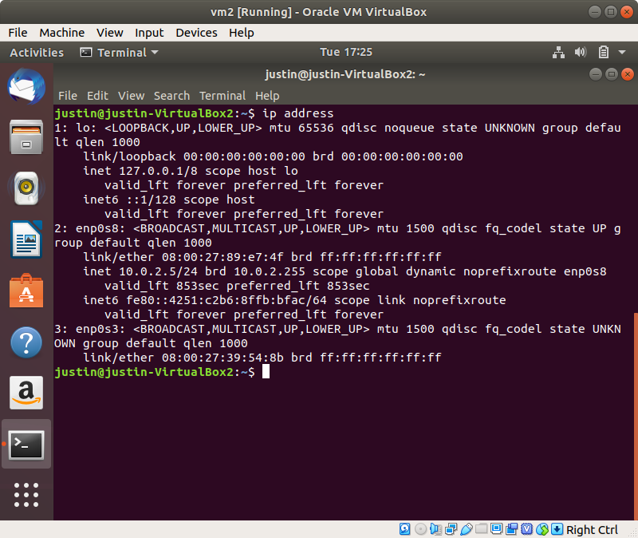

g. dd - copy bytes files from specified input to output. Shows performance.

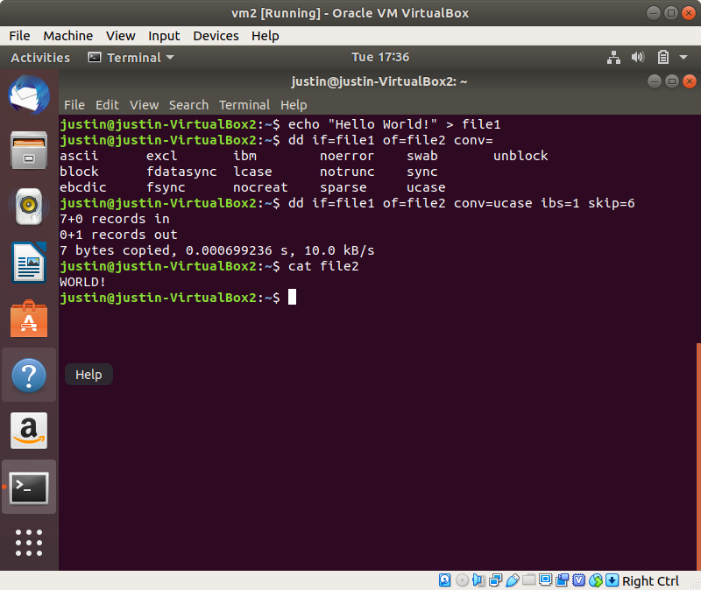

h. fdisk - Manage the partition of a disk device

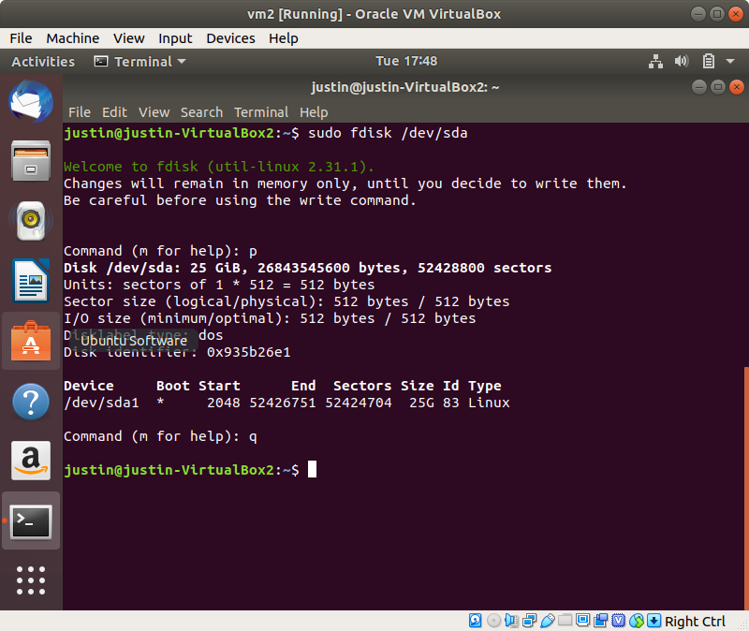

i. apt - the command line interface for the package manager in ubuntu. Use to install and remove packages.

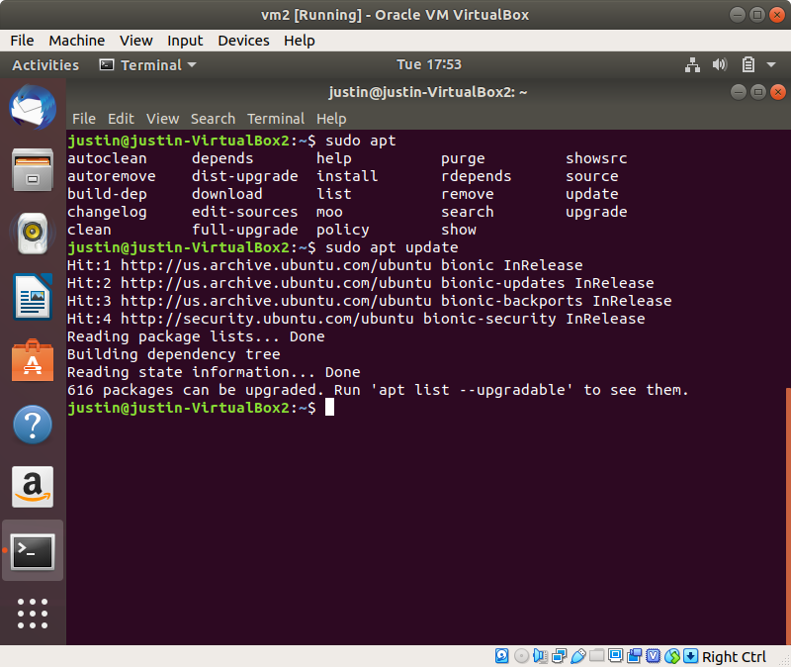

j. vi - lightweight text editor

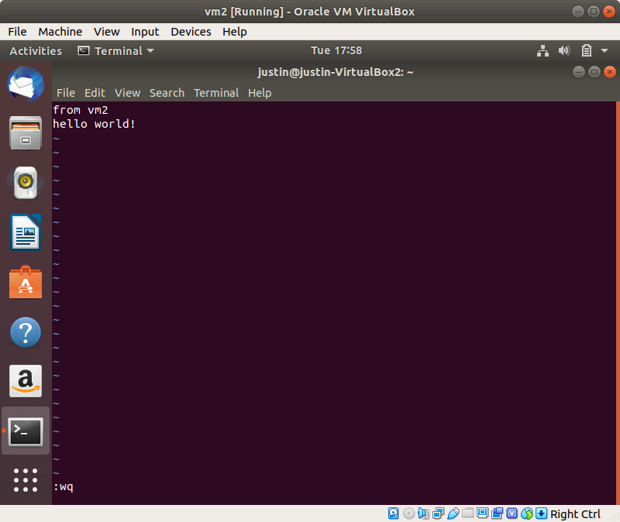

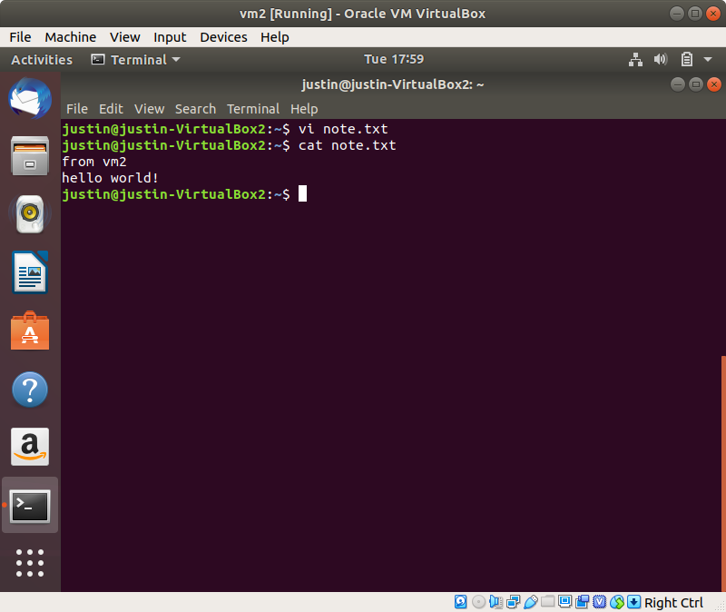

k. time - show the execution time of a program

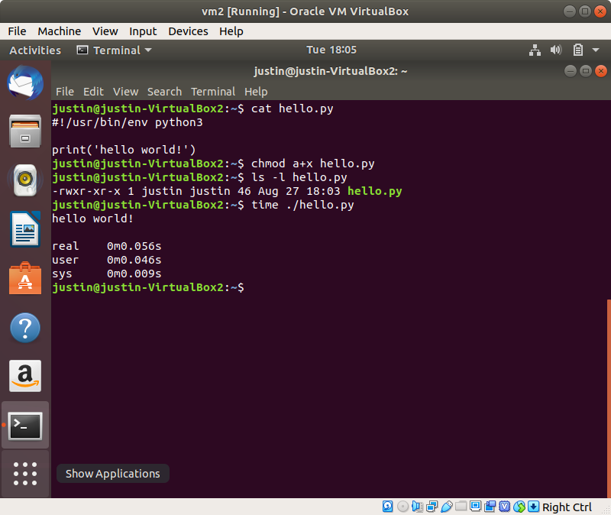

l. tar - archive and compress files and directories, and also extracts created archives

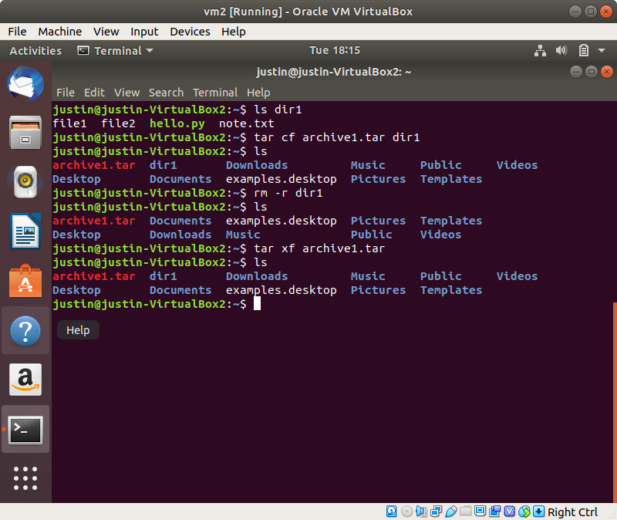

m. cat - print contents of file to standard output

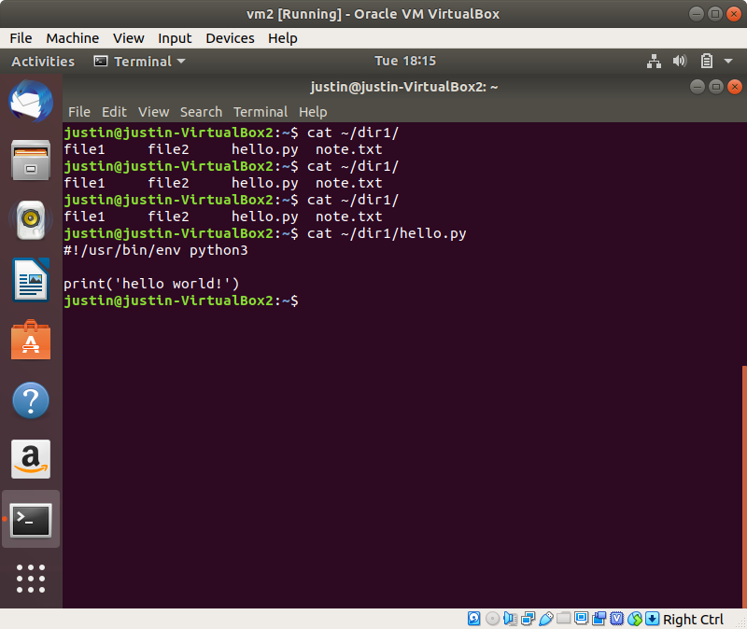

n. watch - periodically execute a command in the shell, while displaying the output on every execution.

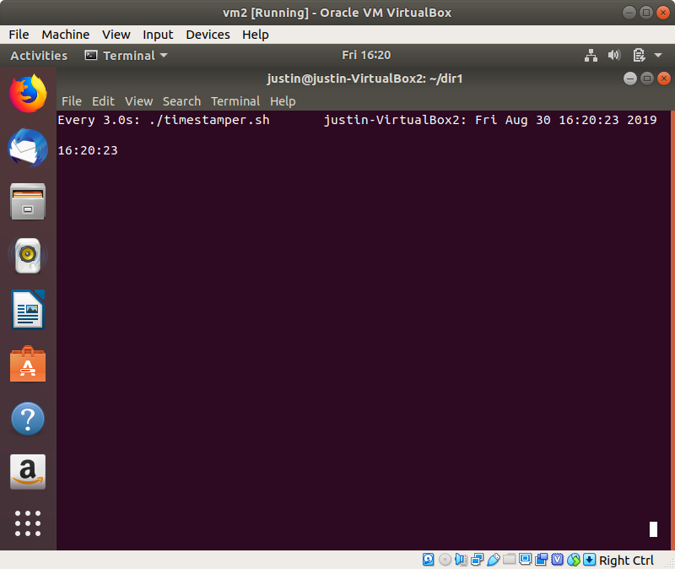

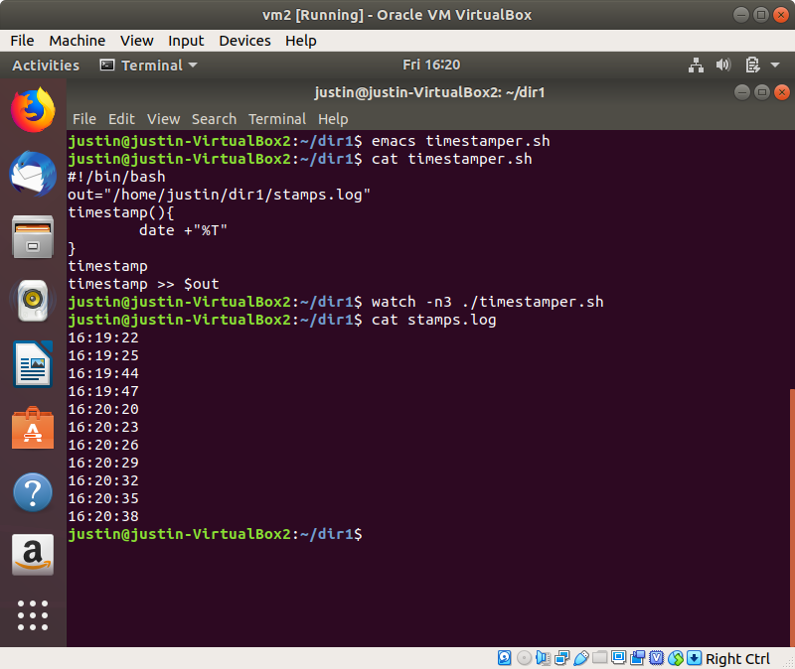

o. ps - display current running processes

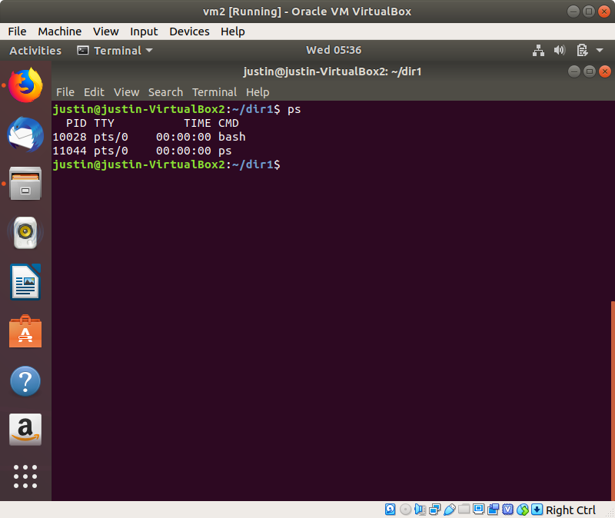

p. top - Display all running linux processes, dynamically

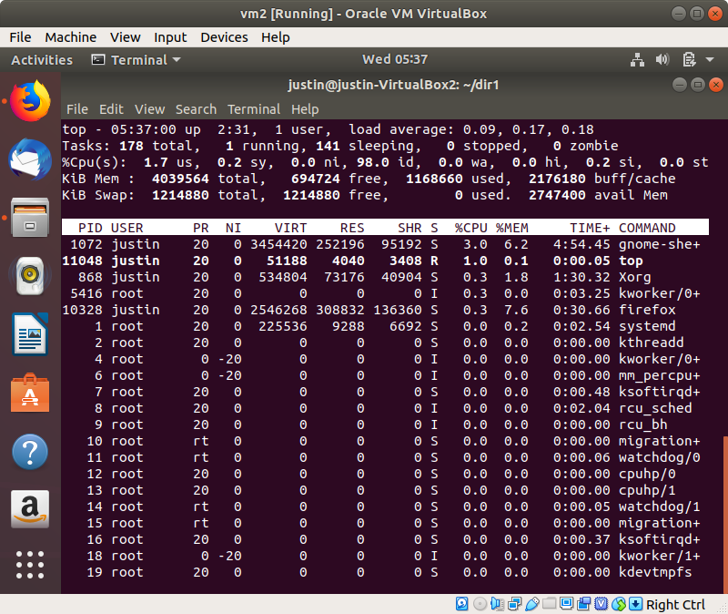

q. htop - A “prettier” top, with more functionalities (e.g. select multiple processes at once)

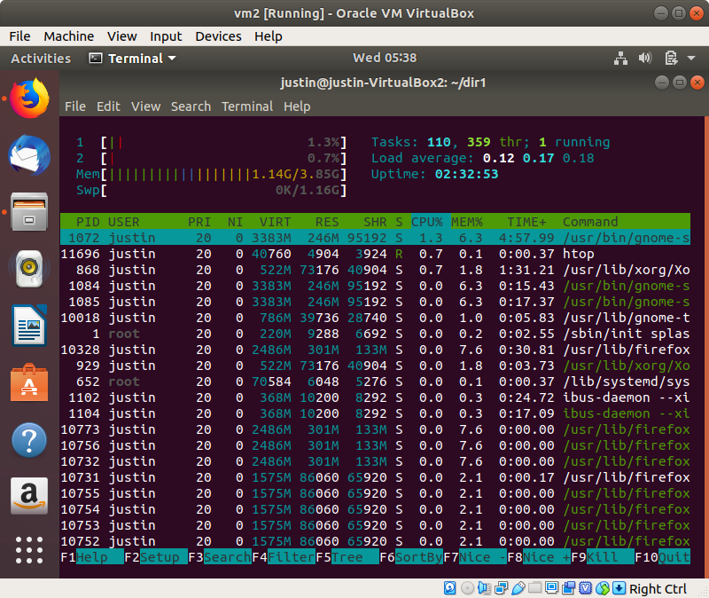

r. gcc - GNU C compiler

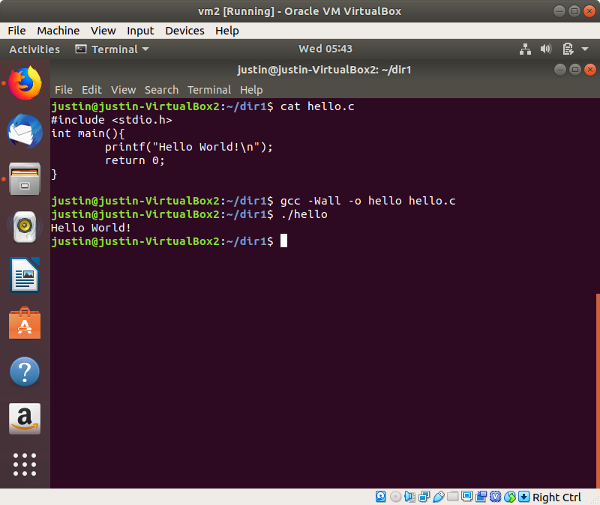

s. tail - print the last lines of a file to stdout

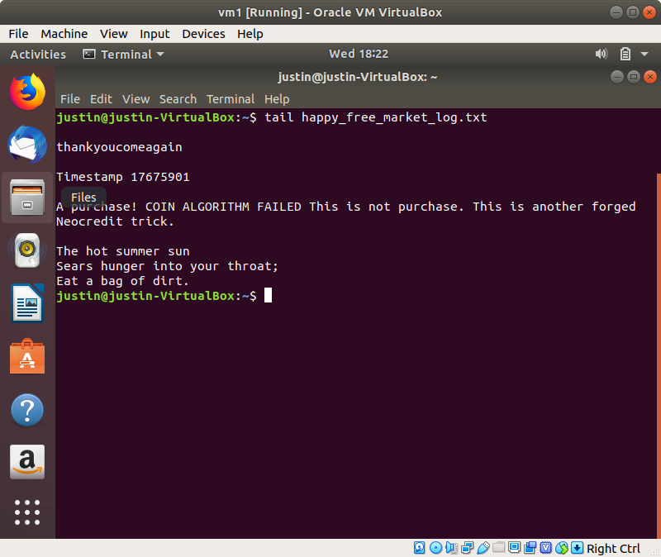

t. grep - a text filter program that finds matches from input files using regex.

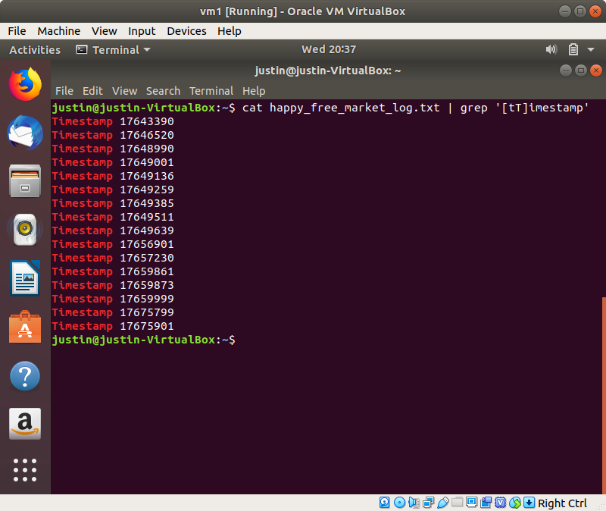

u. kill - terminate a running process

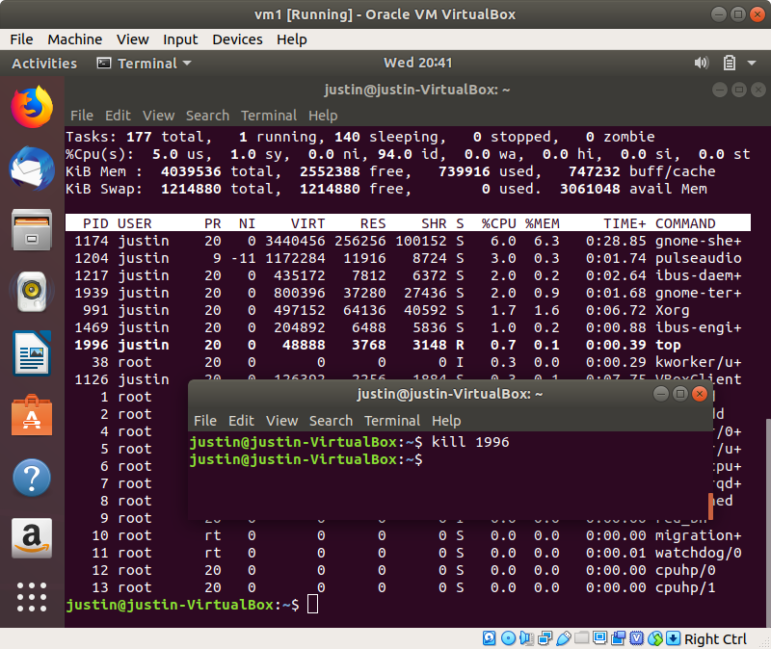

v. killall - terminate all processes with the provided program name

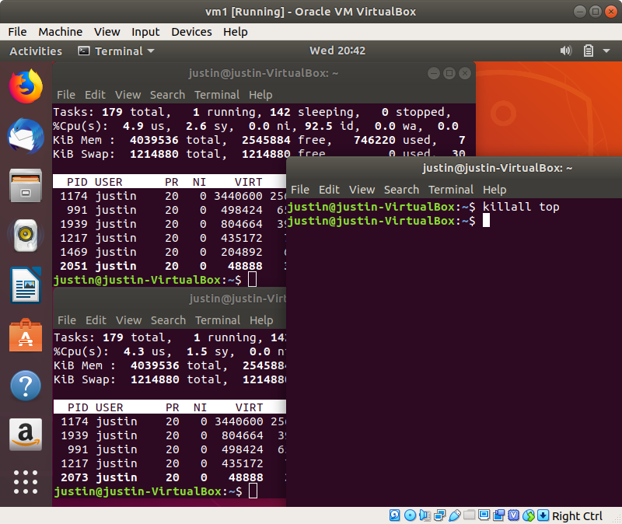

w. du - Estimate the file sizes in the given directory

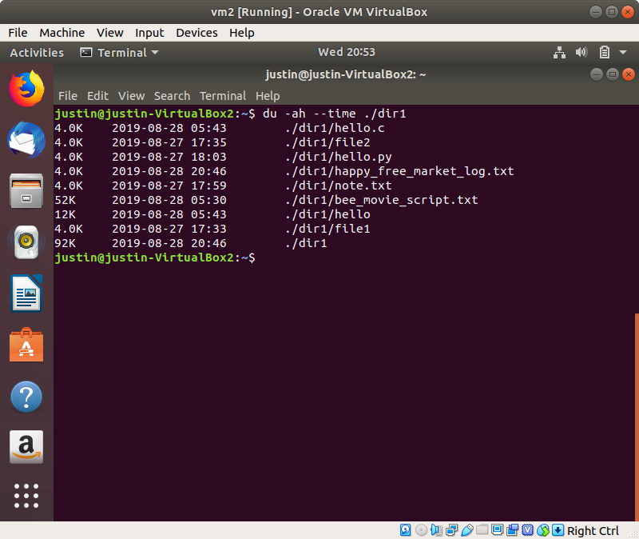

x. df - Display the filesystem usage and disk availability

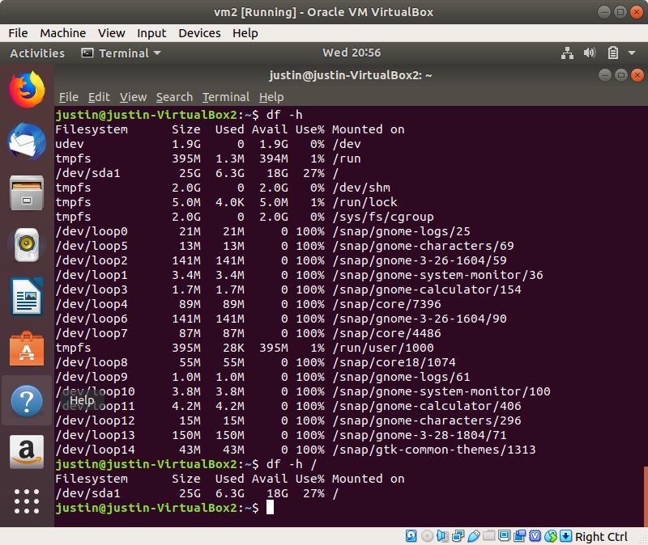

y. screen - run processes in the background, with command logging functionalities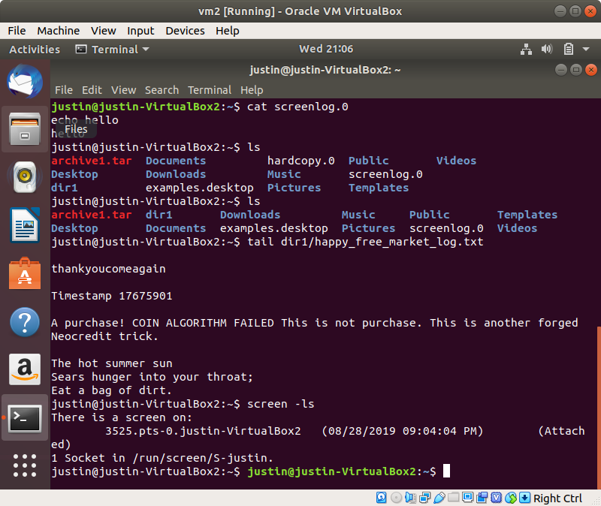

z. vim - Text editor, VI iMproved

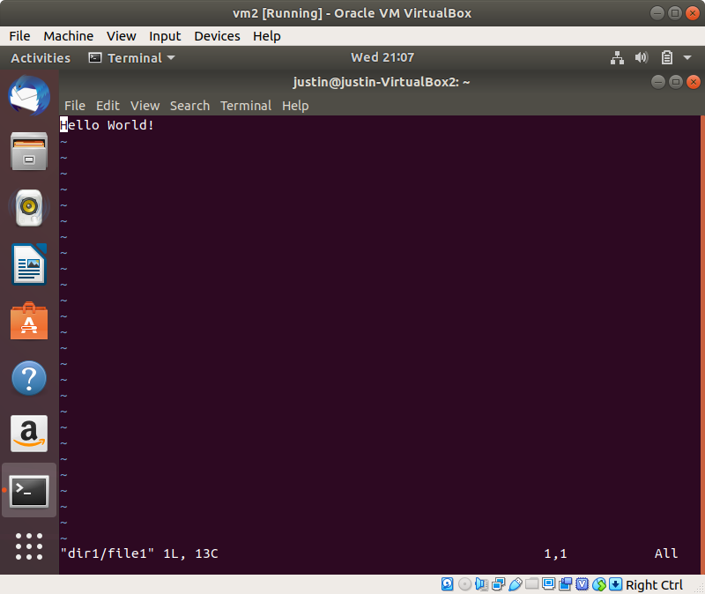

aa. chmod - change the permissions of a file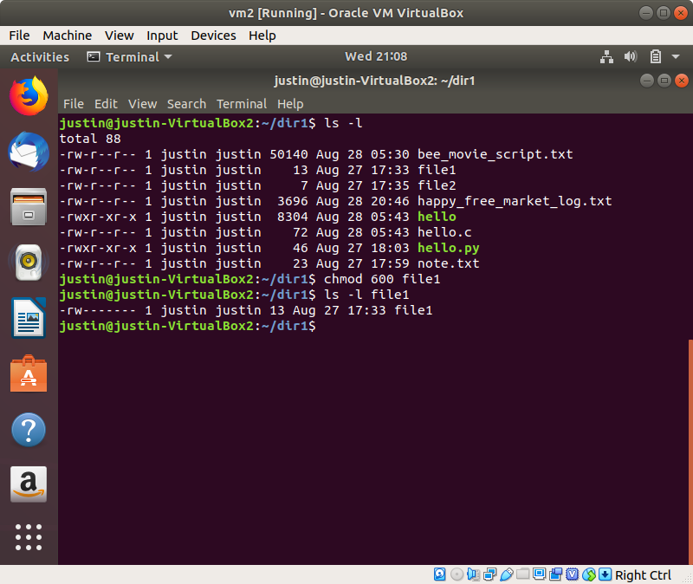

bb. chown - change the owner of a file

cc. useradd - add a user to the system

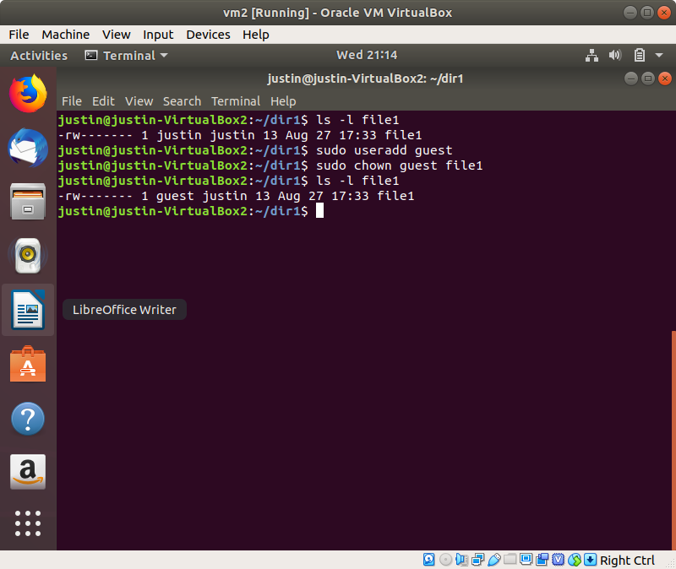

dd. man - show the manual of a command

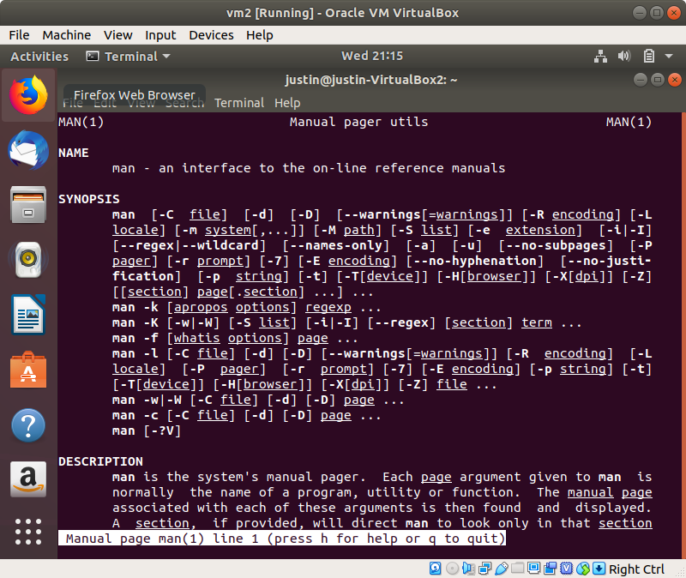

ee. locate - find a file by name, in the given directory

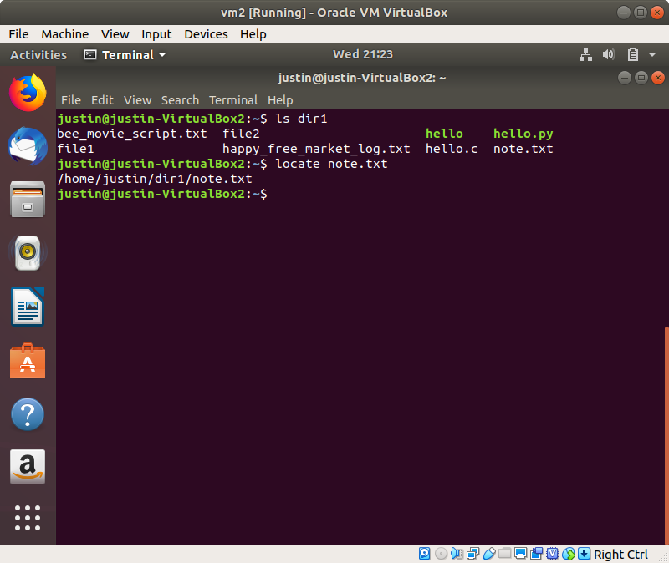

ff. find - find a file with the given filename, display all matches.

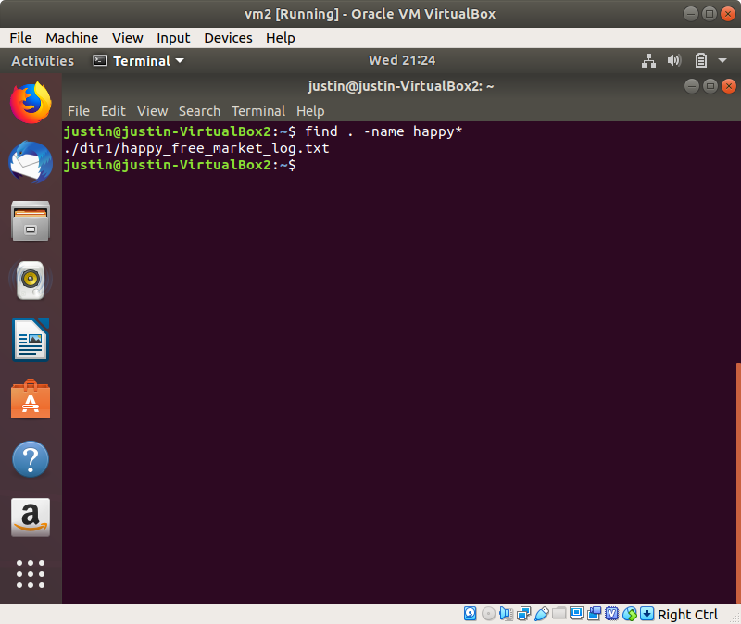

gg. sed - Match and replace text from a provided text stream

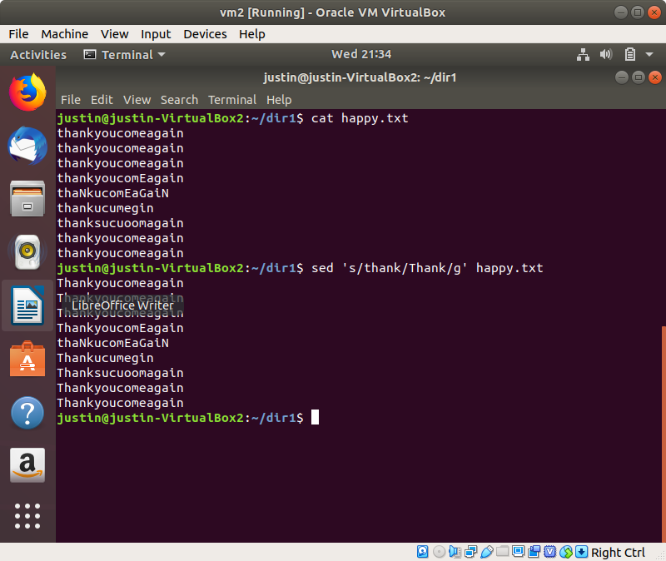

hh. awk - an interpreted programming language for text processing (matching, formatting, etc)

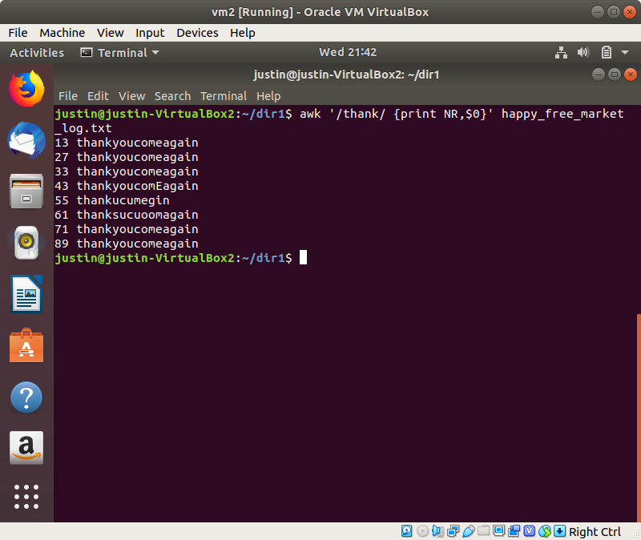

ii. diff - compare two files, line by line, and display the differences

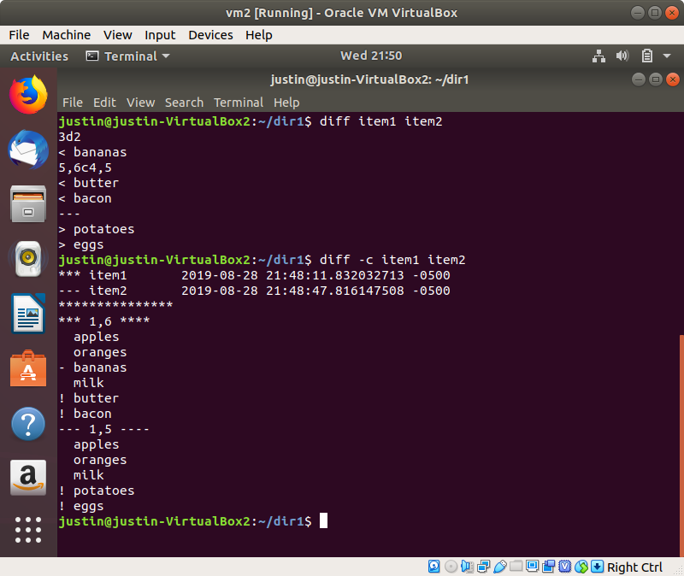

jj. sort - sort the file by line (alphabetically/numerically)

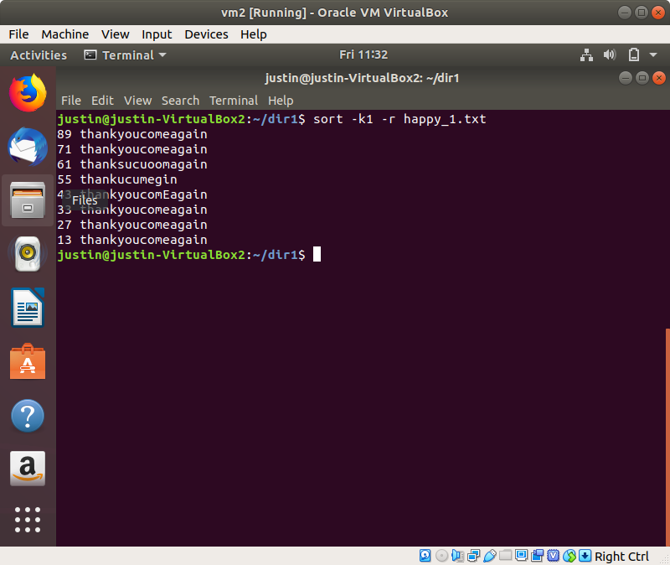

kk. export - Show all bash environment variables

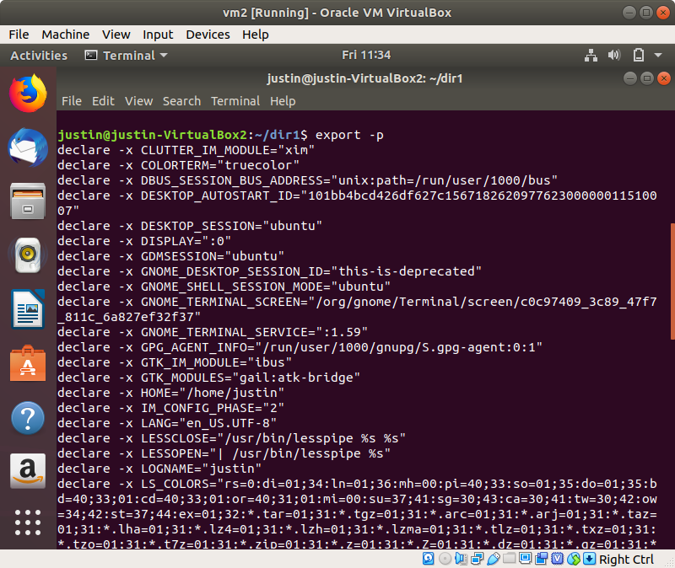

ll. pwd - print current working directory path

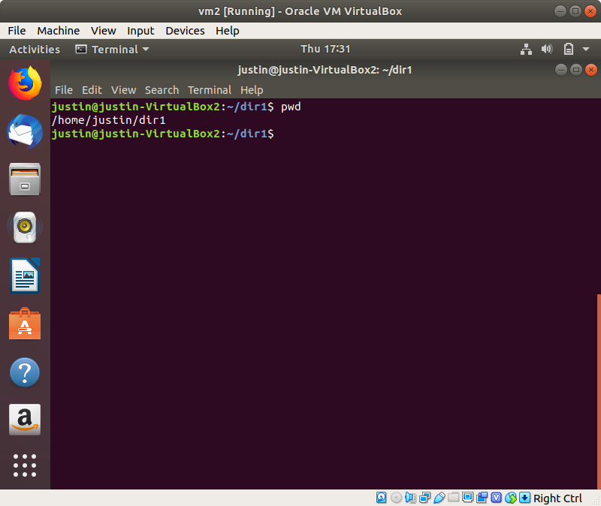

mm. crontab - schedule tasks to the cron daemon to run periodically.

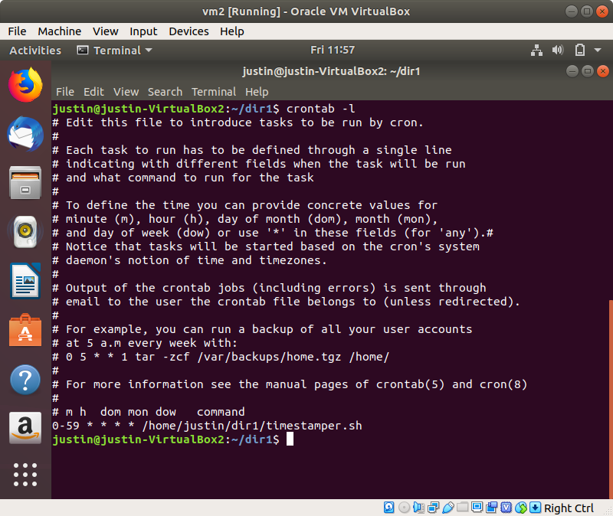

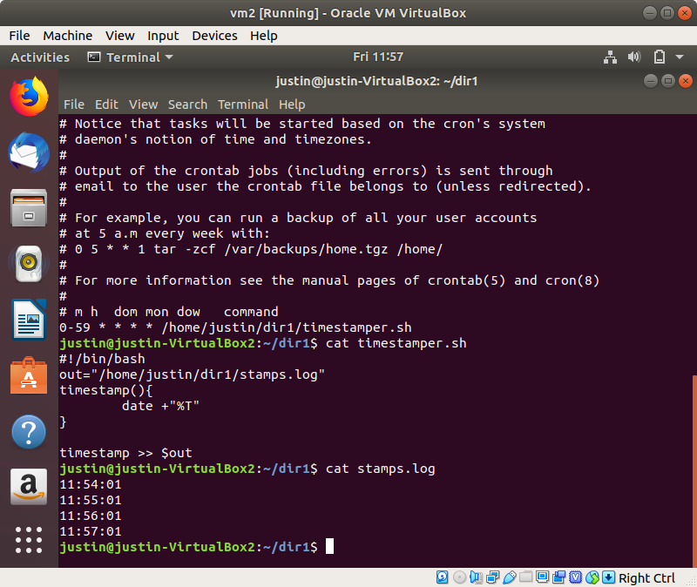

nn1. Create a disk in VirtualBox

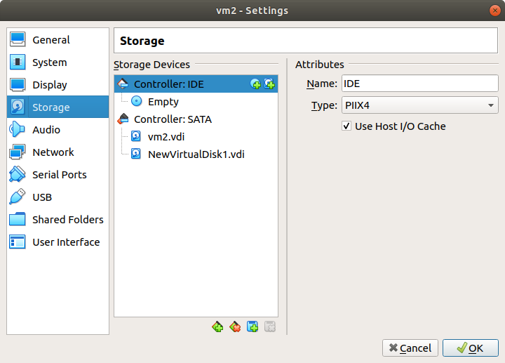

nn2. List the available devices with lsblk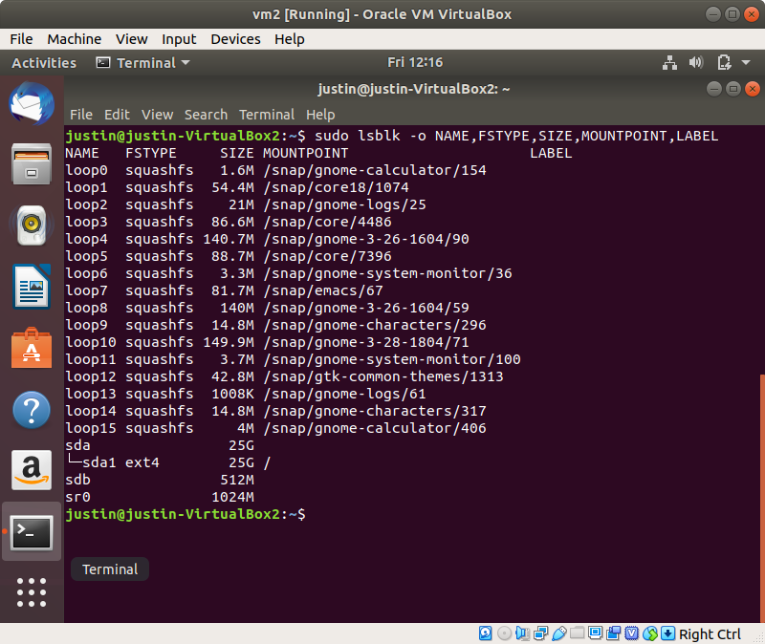

nn3. Create a new partition with fdisk

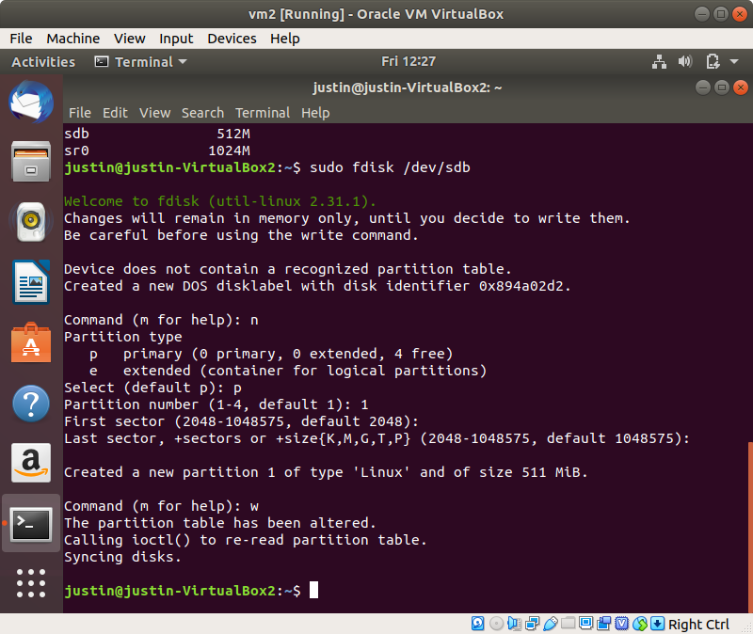

nn4. Mount the partition to the filesystem

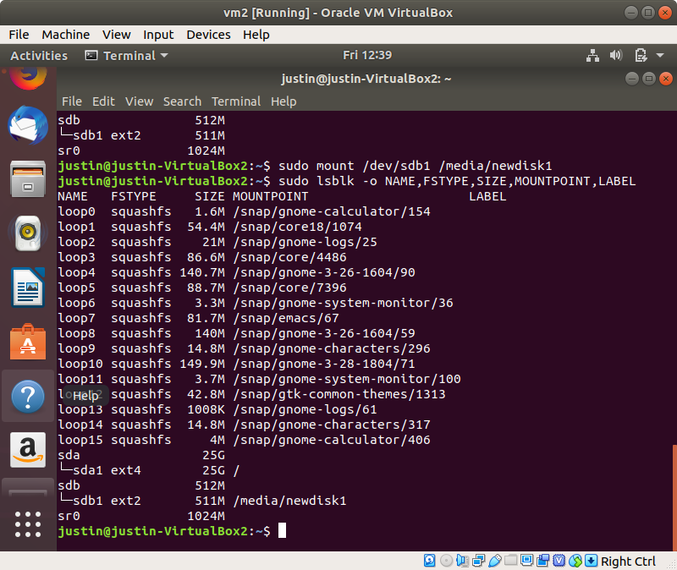

oo. passwd - change the password for a user

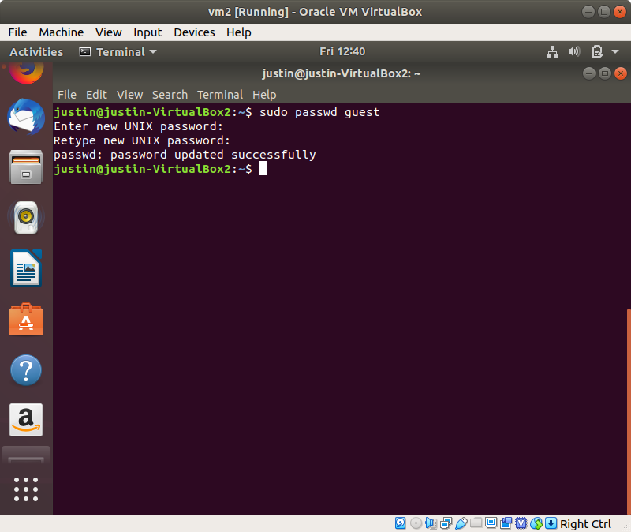

pp. uname - display system information of the current machine

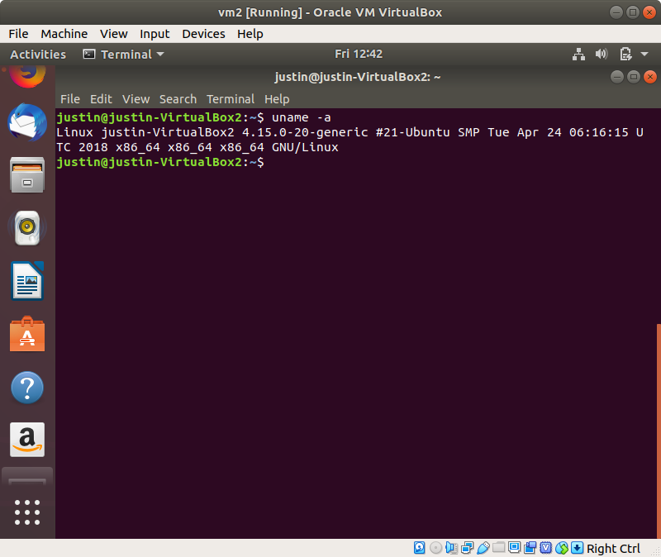

qq. whereis - Show the path of the executable of the given command

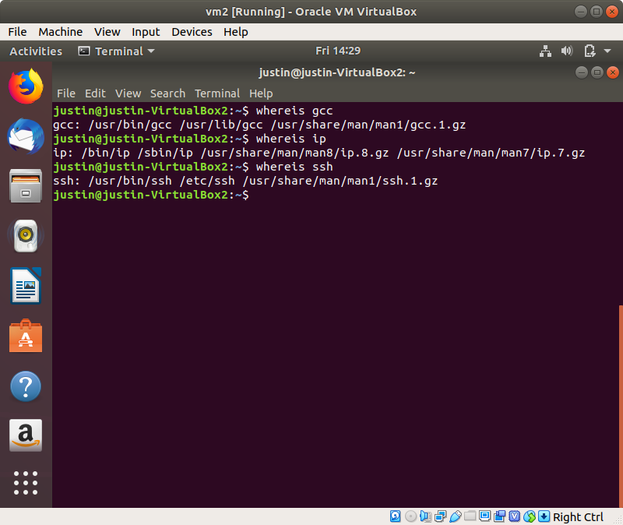

rr. whatis - Short description of the given command

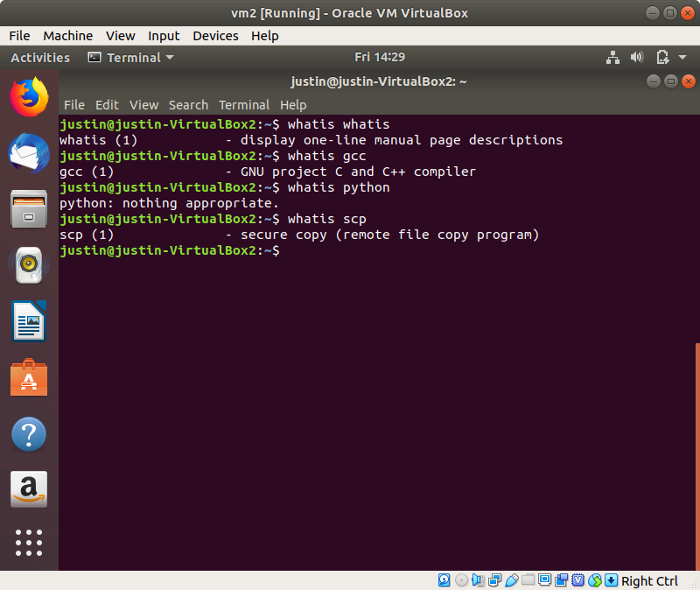

ss. su - Change the current user to another user in the system

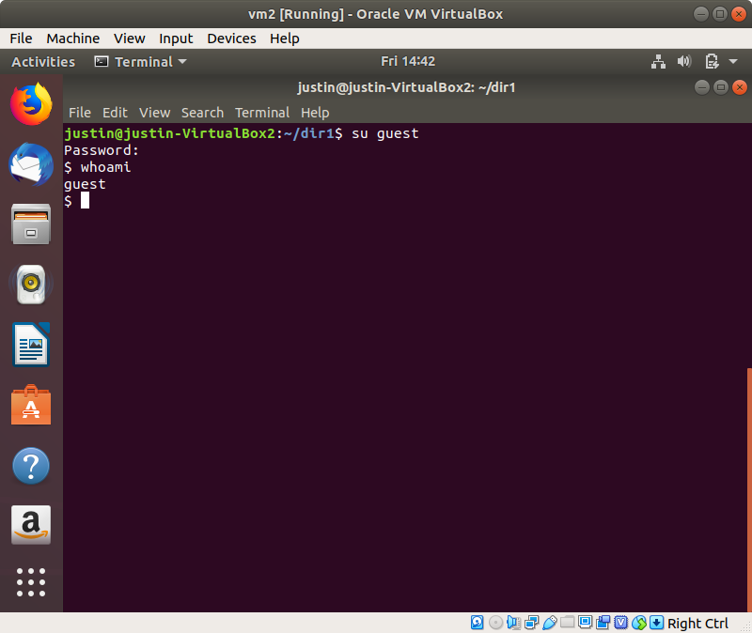

tt. ping - Ping a remote host, and show latency statistics

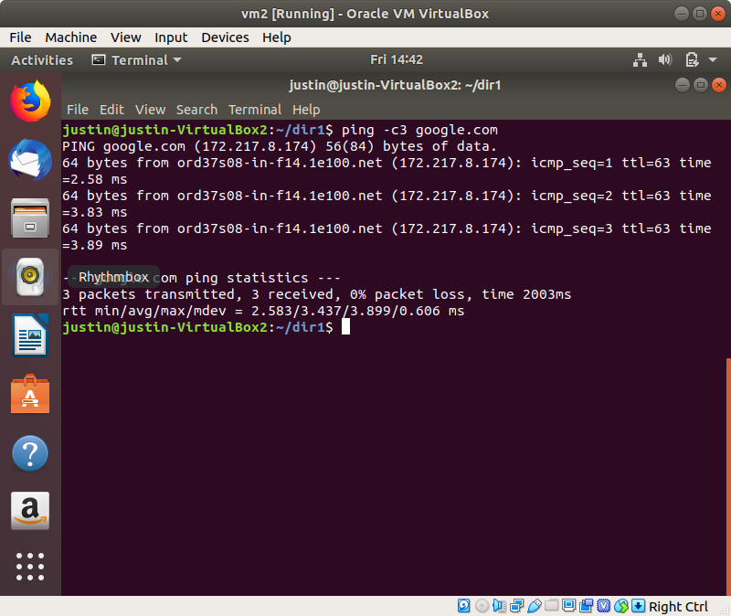

uu. traceroute - trace the routing of the sent packets

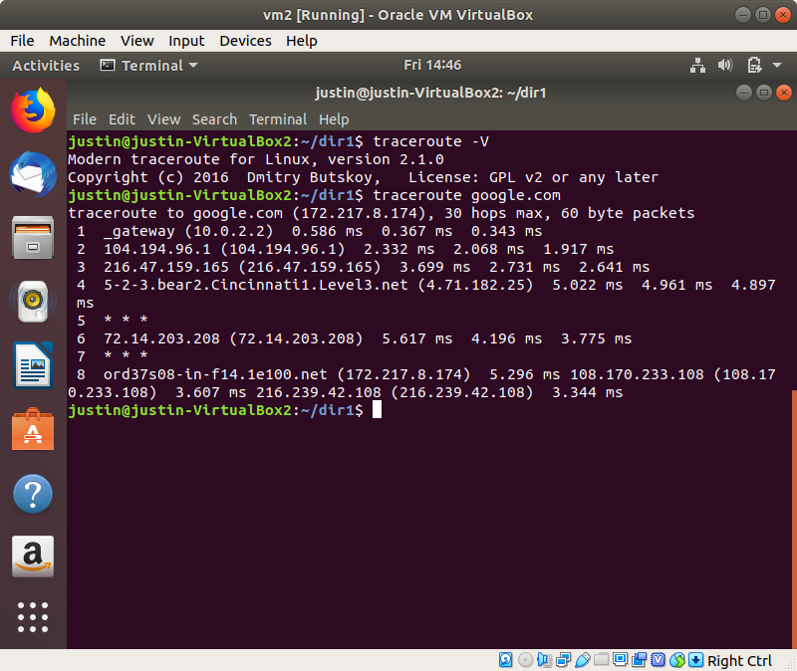

vv. date - display the current date and time of the system

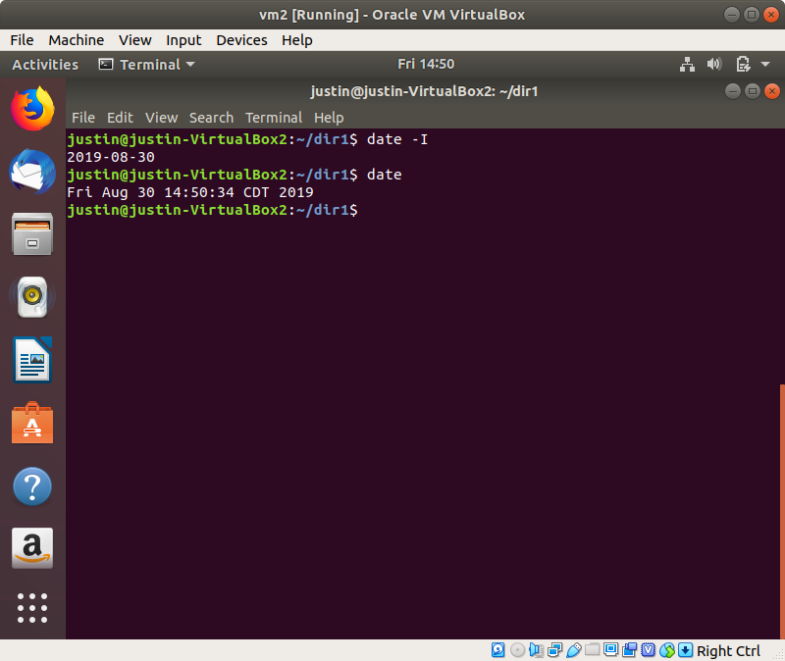

ww. time - show the execution time of a program (Real - start to finish, user - user-mode time, sys - kernel-mode time)

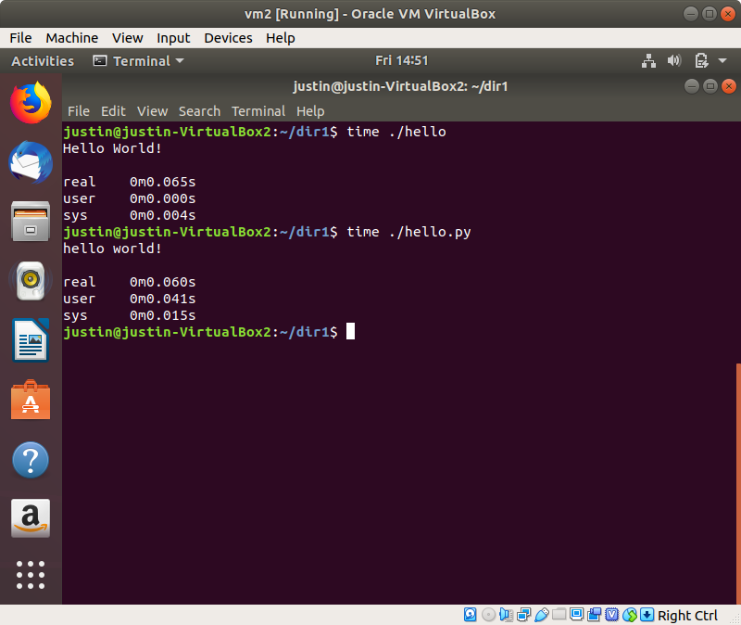

xx. wget - download a file using standard communication protocols (http, https, ftp)

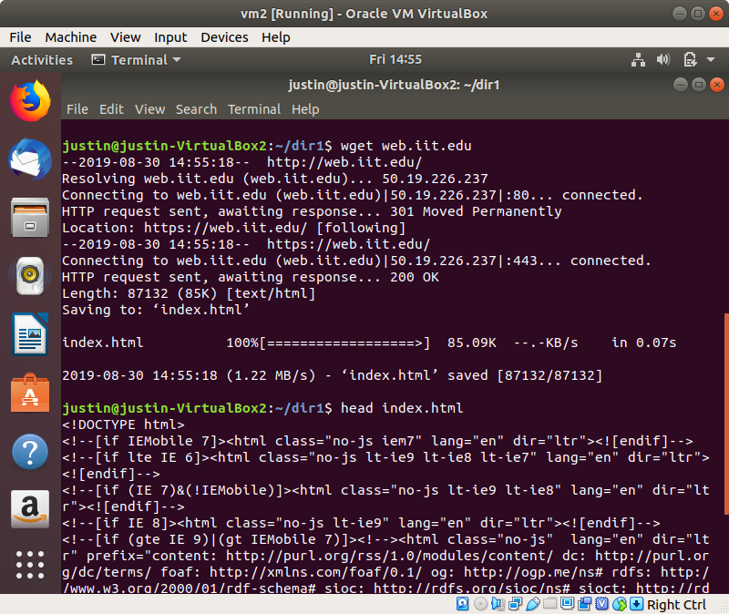

yy. wc - word count, counts the number of newlines, words, and bytes in a file

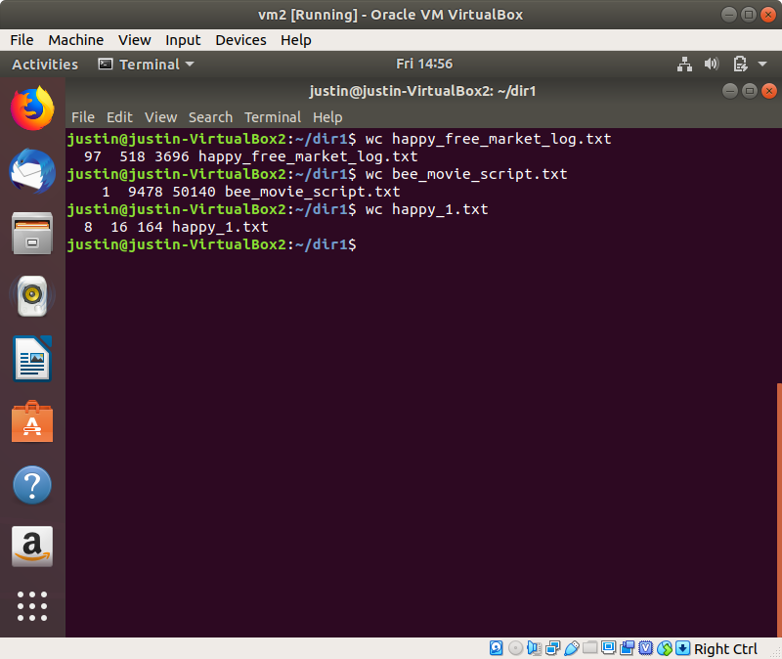

zz. pwgen - generate pronounceable passwords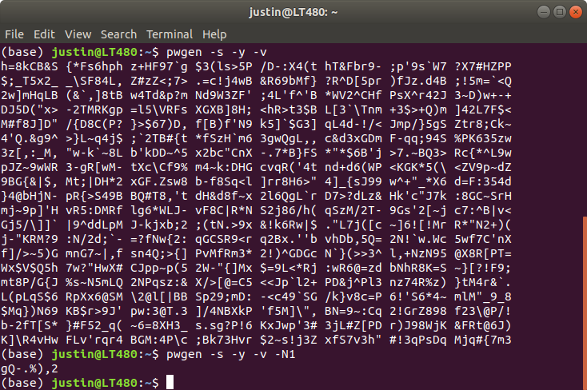

Q3a results from the terminal

(base) justin@LT480:~/team-25/hw1/src$ time ./generate-dataset.sh file1.txt 10000

File created, filename - "file1.txt" - (10000)

real 0m8.445s

user 0m6.994s

sys 0m1.993s

(base) justin@LT480:~/team-25/hw1/src$ time ./generate-dataset.sh file1.txt 100000

File created, filename - "file1.txt" - (100000)

real 1m31.469s

user 1m14.306s

sys 0m22.889s

(base) justin@LT480:~/team-25/hw1/src$ wc file1.txt

100000 300000 12165111 file1.txt

(base) justin@LT480:~/team-25/hw1/src$ tail -n 5 file1.txt

972229588 76301292 5u3Gtvl6GMKS4FmJyKlfVNHtbzFZRswomIu7xXNNZguZtwlvR5LjrihwLyl3jTFBMtWLgNPzvnEElhvceJHSjdd8rC69szCMJ1W4

85006687 833714007 mZQd1asRzbKGK24zEaOcLhIHBOIPRe4aAPI13AsUYWfiltUFfuYcFhlde6D5G4j52L9xpNX7RhyuFeMrIZ6pW3EPtP8GjEKAnXJY

2922710006 1646520436 iNoVZlwSn1TIK1eGSTdMj2TB5lnYvwaCAry96FiPAX31Wc2xSBU5R8fm96p64EyGY27tYDj5IcvoXD6F8UbwUp9UX4ByEWb5W8of

114834580 1695610962 cETe6IraGTG9j05IJ35bpRMXz9uyLo7IOdfz06tVN4FOYAr6o8viFydljTvfKiumImGSuC6Vrj4ESeWXNbRSDoUM8GA51Lu9S80V

41830450 1182126752 si1P2a7No51xL2NqjN30fJmwqTYwRmTOL9jZNJlYZX5W8NJ5ZUSs1Adu5cMDVHYkB9A7YXr69zcWfdiHAbQZfWQwStK9urUwQjtN

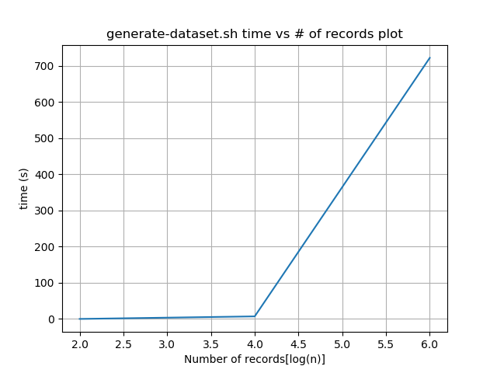Q3c

Plot for generate-dataset.sh:

Plot for sort-data.sh:

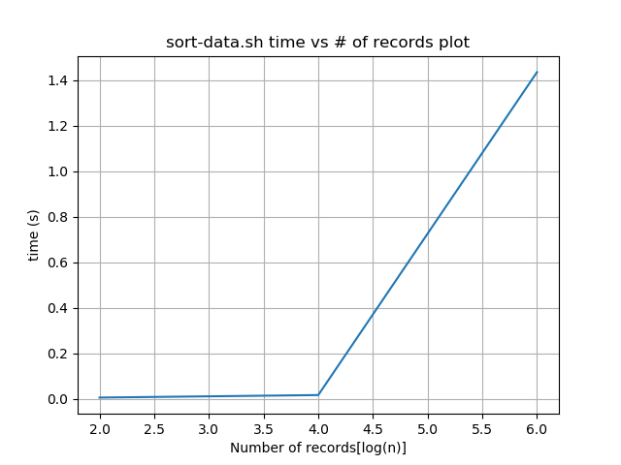

4. (15 points) Answer the following questions about VMs:

a. In the system configuration of the VM, explain how changing the number of processors

changes the behavior of your VM. Explain a scenario where you want to set this to the minimum, and a scenario where you want to set it to the maximum. Why is setting it to the maximum potentially a bad idea?

We can change the number of processors we want to assign for the VM. Giving different number of processors will affect the computing ability of VM. In general, more processors brings higher performance. However, setting the number of processors to maximum will sometimes decrease the overall performance of both VM and the computer due to the fact that the host operating system won’t have enough computing resources to perform background tasks. Therefore, to decide how many processors we should give to VM, we should think about what kind of tasks we expect the VM do. If we just want to use some desktop applications or run some simple programs. We can simply set the number of processors to the minimum. On the other hand, if we expect the VM to video encoding or run a huge data model, we can consider to raise the number of processors to the maximum.

b. In the system configuration of the VM, under the Acceleration Tab, explain the difference between the paravirtualization options: None, Legacy, Minimal, Hyper-V, and KVM. Explain which one would be best to use with Ubuntu Linux, and why.

None: Specifying none explicitly turns off exposing any paravirtualization interface.

Legacy: The legacy option is chosen for VMs which were created with older VirtualBox versions and will pick a paravirtualization interface while starting the VM with VirtualBox 5.0 and newer.

Minimal: Announces the presence of a virtualized environment. Additionally, reports the TSC and APIC frequency to the guest operating system. This provider is mandatory for running any Mac OS X guests.

KVM: Presents a Linux KVM hypervisor interface which is recognized by Linux kernels starting with version 2.6.25. VirtualBox's implementation currently supports paravirtualized clocks and SMP spinlocks. This provider is recommended for Linux guests.

Hyper-V: Presents a Microsoft Hyper-V hypervisor interface which is recognized by Windows 7 and newer operating systems. VirtualBox's implementation currently supports paravirtualized clocks, APIC frequency reporting, guest debugging, guest crash reporting and relaxed timer checks. This provider is recommended for Windows guests.

**We should use KVM for our Ubuntu because it is recognized by Linux kernels and it is recommended for Linux guests.**

c. In storage devices when configuring the VM, there are multiple types of storage controllers: explain the difference between the IDE, SATA, and NVMe controller. Give an example for each type of storage controller of a scenario where you may want to use this type of controller.

IDE: IDE (ATA) controllers are a backwards-compatible yet very advanced extension of the disk controller in the IBM PC/AT (1984). Initially, this interface worked only with hard disks, but was later extended to also support CD-ROM drives and other types of removable media. In physical PCs, this standard uses flat ribbon parallel cables with 40 or 80 wires. Each such cable can connect two devices to a controller, which have traditionally been called master and slave. Typical PCs had two connectors for such cables. As a result, support for up to four IDE devices was most common.

SATA: Serial ATA (SATA) is a more recent standard than IDE. Compared to IDE, it supports both much higher speeds and more devices per controller. Also, with physical hardware, devices can be added and removed while the system is running. The standard interface for SATA controllers is called Advanced Host Controller Interface (AHCI).

NVMe: Non volatile memory express (NVMe) is a standard for connecting non volatile memory (NVM) directly over PCI Express to lift the bandwidth limitation of the previously used SATA protocol for solid-state devices. Unlike other standards the command set is very simple in order to achieve maximum throughput and is not compatible with ATA or SCSI. OSes need to support NVMe devices to make use of them.

**Based on the document of VirtualBox, it suggests to avoid IDE unless it is the only controller supported by your guest. Moreover, after I did some research, NVMe seems cause some problems when your using it in some OSes. Since that storage controllers are just virtual controllers so it won’t actually affect the performance of the guest too much(we don’t need to choose NVMe controller if host is running on NVMe SSD). In other words, unlike a physical NVMe, choosing a virtual NVMe controller won’t actually brings you much benefit. Therefore, I suggest to use SATA in general cases.**

d. In the network configuration of the VM, there are multiple types of network adapters: explain the difference between NAT, Bridged Adapter, Internal Network, and Host-only Network. Give an example for each type of network of a scenario where you may want to use this type of network.

NAT: Network Address Translation (NAT) is the simplest way of accessing an external network from a virtual machine. Usually, it does not require any configuration on the host network and guest system. For this reason, it is the default networking mode in Oracle VM VirtualBox.

A virtual machine with NAT enabled acts much like a real computer that connects to the Internet through a router. The router, in this case, is the Oracle VM VirtualBox networking engine, which maps traffic from and to the virtual machine transparently. In Oracle VM VirtualBox this router is placed between each virtual machine and the host. This separation maximizes security since by default virtual machines cannot talk to each other. **Choose this if all you want is to browse the Web, download files, and view email inside the guest.**

Bridged Adapter: This is for more advanced networking needs, such as network simulations and running servers in a guest. When enabled, Oracle VM VirtualBox connects to one of your installed network cards and exchanges network packets directly, circumventing your host operating system's network stack. **Choose this if you want your VM be visible to the outside world and host. For example, build a server in VM.**

Internal Network: This can be used to create a different kind of software-based network which is visible to selected virtual machines, but not to applications running on the host or to the outside world. Internal Networking is similar to bridged networking in that the VM can directly communicate with the outside world. However, the outside world is limited to other VMs on the same host which connect to the same internal network. **Choose this for security concern. For example, you prefer two or more VMs on the same machine to communicate privately, hiding their data from both the host system and the user,**

Host-only Network: This can be used to create a network containing the host and a set of virtual machines, without the need for the host's physical network interface. Instead, a virtual network interface, similar to a loopback interface, is created on the host, providing connectivity among virtual machines and the host. **Host-only networking is particularly useful for preconfigured virtual appliances, where multiple virtual machines are shipped together and designed to cooperate. For example, one virtual machine may contain a web server and a second one a database, and since they are intended to talk to each other, the appliance can instruct Oracle VM VirtualBox to set up a host-only network for the two. A second, bridged, network would then connect the web server to the outside world to serve data to, but the outside world cannot connect to the database.**

e. For the USB configuration of the VM, explain the difference between USB 1.1, 2.0, and 3.0 controllers.

USB 1.1: OHCI

USB 2.0: EHCI + OHCI

USB 3.0: This supports all USB speeds.

5. (20 points) Answer the following questions about computer processors:

a. Describe what a core and hardware thread is on a modern processor, and the difference

between them?

|  |
| --- |
| A CPU core is a hardware component that has a dedicated set of registers, arithmetical  logical unit(s), addressing unit and a control unit that can execute instructions, manipulate  data in memory and handle interrupts.  A hardware thread is a technique that allows CPU vendors to connect multiple instruction and data pipelines to a single core, providing additional sets of registers that allows the core to switch between the pipelines without offloading state to main memory, thus increasing performance of IO intensive applications. They may be exposed to the operating system and programmers as appearing to be additional cores. |

b. How many cores do the fastest processors from each manufacturer have? Give an

example (specific model, specs, and price).

(a) Intel CPU (x86)

|  |
| --- |
| <https://ark.intel.com/content/www/us/en/ark/products/194146/intel-xeon-platinum-9282-processor-77m-cache-2-60-ghz.html>  Intel Xeon Platinum 9282 Processor  Launch Date: Q2’19  Lithography: 14nm  # of Cores: 56  # of Threads: 112  Processor Base Frequency: 2.60Ghz  Max Turbo Frequency: 3.80Ghz  Cache: 77MB  TDP: 400W  “Prices for these models will not be made public since the processors are BGA-only and will be sold directly to select OEMs in 2U quad-blade configurations. These new server blades will start shipping in Q2 2019.”  <https://www.notebookcheck.net/Intel-presents-new-56-core-Xeon-Platinum-server-grade-CPUs.415676.0.html> |

(b) AMD CPU (x86)

|  |
| --- |
| <https://www.amd.com/en/products/cpu/amd-epyc-7742>  AMD EPYC 7742  Launch Date: Q2’19  # of Cores: 64  # of Threads: 128  Processor Base Frequency: 2.25Ghz  Max Turbo Frequency: 3.40Ghz  Total L3 Cache: 256MB  TDP: 225W  Price: $7,522.99 <https://www.newegg.com/amd-epyc-7742-socket-sp3/p/N82E16819113581> |

(c) IBM CPU (Power9)

Power9 - instruction set developed by IBM

|  |
| --- |
| <https://en.wikichip.org/wiki/ibm/microarchitectures/power9>  <https://en.wikichip.org/wiki/ibm/power/02cy296>  Model: 02CY296  Launch Date: November 2018  # of Cores: 22  # of Threads: 88  Processor Base Frequency: 2.75Ghz  Max Turbo Frequency: 3.80Ghz  L3: 110MB  TDP: 190W |

(d) ThunderX CPU (ARM)

|  |
| --- |
| <https://www.marvell.com/documents/6vi7chuyqr17kc25llol/>  ThunderX_CP™ Family of Workload Optimized Compute Processors  # of Cores: up to 48  Processor Frequency: up to 2.5Ghz  Cache: 78K-Icache and 32K-D cache per core, 16 MB shared L2 cache |

(e) NVIDIA GPU

|  |
| --- |
| Nvidia Quadro RTX 8000  GPU Memory 48 GB GDDR6  Memory Interface 384-bit  Memory Bandwidth 672 GB/s  NVIDIA CUDA Cores 4,608  NVIDIA Tensor Cores 576  NVIDIA RT Cores 72  Single-Precision Performance 16.3 TFLOPS  Tensor Performance 130.5 TFLOPS  Price: $5531.99  <https://www.amazon.com/PNY-VCQRTX8000-PB-NVIDIA-Quadro-Graphic/dp/B07NH3HKG9> |

c. Why do we not have processors running at 1THz today (as might have been predicted in

the year 2000)?

|  |
| --- |
| Increasing clock frequencies lead to a higher thermal loss. Sufficient cooling is required to maintain operational temperatures, otherwise the chip will be damaged and fail. Chips that operate at higher clock frequencies endures higher thermal stress, and would have lower mean time before failure.  Secondly, an increase in clock frequencies implies an increase in voltage, and thus power consumption. In data centers and other intensive environments, power costs is an important factor. |

d. Describe Moore’s Law. Is it going to go on forever? If not, when will it end? Justify your

answer to why it will end and when.

|  |
| --- |
| Moore’s Law states that the number of transistors that can be packed into a given unit of space will double about every two years. Many experts agrees that Moore’s Law is coming to an end in 2020s, where manufacturing smaller transistors becomes physically impossible. As transistors are made smaller, eventually it reaches a certain point where quantum tunneling of electrons would render the miniaturized transistors produces inconsistent results and becomes non-functional. |

Question 6 :

a. Why is threading useful on a single-core processor?

On a single -core processor, threading allows multiple instructions to be processed at a time.

b. Do more threads always mean better performance?

More threads do not always imply a better performance. If we have too many threads for a simple process, it could take more time. Or if a program is not designed to use multiple threads, having many threads will not improve the performance.

c. Is super-linear speedup possible? Explain why or why not.

Super-linear speedup is possible if the task given is embarrassingly parallelizable. As we split the data into smaller pieces, it is possible that the size of the data becomes small enough such that it fits into higher memory hierarchy component (e.g. from memory → L3 cache, or L3 cache → L2 cache etc), which often times the speeds up comes in chunks. Together with more cores, the speed up is possible to be super-linear.

1. Why are locks needed in a multi-threaded program?

Locks are abstractions provided by the operating systems to coordination shared resources across threads. They are used to avoid race-conditions in programs. For instance, if two threads increment the same variable, at the end it’s not guaranteed that we will have the expected value. To avoid that, we have to use locks to control the access to the variable.

1. Would it make sense to limit the number of threads in a server process?

It makes sense to limit the number of threads in a server process because a processor core can have 2 threads at most normally. Introducing too many threads would incur a high overhead to the system, thus lowering the overall performance.

- End -